Chapter 3
Fire Department Communications

Lesson Goal
After completing this lesson, the student shall be able to discuss on-scene communications and postincident reports.
Objectives
Upon successful completion of this lesson, the student shall be able to:
1. Describe the aspects that make up on-scene communications. [NFPA® 6.2.2]
2. Explain the information gathered by postincident reports. [NFPA® 6.2.1]
3. Create an incident report. [NFPA® 6.2.1, Skill Sheet 3-II-I]

Instructor Information
This is the lesson covering fire department communications. This lesson describes on-scene communications for a Firefighter II.

Important instructor information is provided in shaded boxes throughout the lesson plan. Carefully review the instructor information before presenting the lesson.

This lesson includes skill evaluation checklists that assess student ability to perform in order to correctly complete an incident report. These checklists will allow students to meet the requirements of Learning Objective 3.

Methodology
This lesson uses lecture, discussion, and skills practice. The level of learning is application.
Outline Contents

Section | Outline Pages | Text Pages
Section I: On-Scene Communications | 5 | 116
Section II: Postincident Reports | 12 | 121
Section III: Skill Sheet | 15 | 128
Section IV: Summary and Review | 15 | 123

Audiovisuals
- Visuals 3.1 to 3.14 (PowerPoint® Presentation)
- Easel pad and marker
Evaluation
- Chapter 3 Quiz
- Chapter 3 Test
- Skill Evaluation Checklist 3-II-1
Presentation Tools
Interactive Objects allow instructors to present information a piece at a time by clicking on hot spots in a larger image.

Each object is labeled in the Lesson Outline and indicated in the PowerPoint® presentation by a RED arrow in the top left corner of the image. This lets instructors know to use the mouse to explore all of the information on the slide.


After all of the information is displayed a reset arrow will appear in the bottom right corner of the image. Instructors can use this to remove the text and quiz students on content just covered or simply move on to the next slide.

To move to the slide after an interactive object, select the Click for next slide arrow on the left side of the slide.

Videos are used as discussion starters or to illustrate a concept or process discussed in the chapter.

These are labeled in the Lesson Outline and indicated in the PowerPoint® presentation by the Click image to play arrow on the left side of the slide.

Section I: On-Scene Communications

On-scene communications
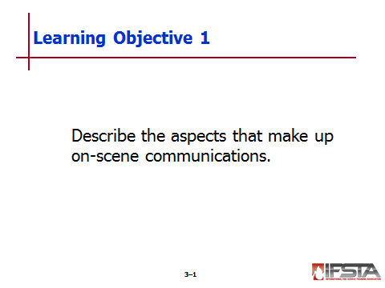
pp. 116-121 Objective 1 — Describe the aspects that make up on-scene communications.

Arrival Report

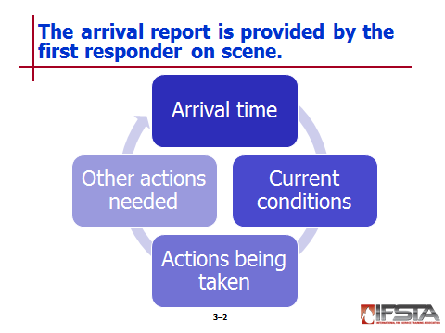
If first on-scene, provide initial radio report – Provide other units, telecommunications center with description of conditions as they appear

Referred to as

Arrival report

Report on conditions

Brief initial report

On-scene report

Situation report

Size-up report

CAN (condition, actions, needs) report

Initial report

Establishes initial arrival time

Informs other responding units of current conditions

Describes actions that are being taken

Describes actions that need to be taken by other responding units

Two basic arrival situations

No visual evidence of emergency, requires more investigation

Obvious signs of emergency requires immediate action

Arrival report should contain

Unit (or individual) arriving on-scene

Correct address of incident if different from dispatch address

Description of conditions found

If structure fire or collapse, description of structure

Number of floors

Type of construction

Type of occupancy

Operational strategy

Intended initial actions

Water supply need or availability

Establishment of Command

Specify who is Incident Commander

State name of incident (may be address or name of occupancy)

State location of Command Post when applicable

State location(s) of staging areas for arriving units

Calls for additional resources

Routing instructions to arriving units

Assignments to arriving units

Tactical radio channel for use if required by local protocols
Instructor Note: In some jurisdictions, the telecommunications center will provide the radio channel to responding units.

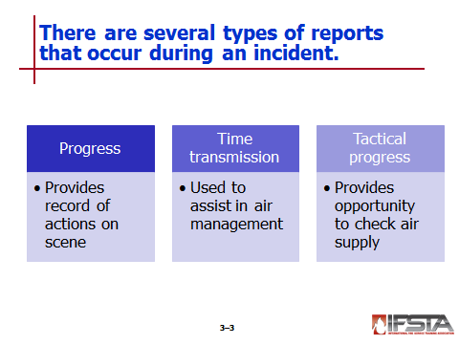
Progress Report

Provides telecommunications center with continuous record of actions at scene

Contain

Transfer of Command

Change in Command Post location

Progress (or lack of) toward incident stabilization

Direction of fire spread

Exposures by direction, height, occupancy, and distance

Any problems

Anticipated actions

Need for additional resources

Telecommunications center may be assigned task of providing periodic time transmissions at designated intervals

Used to assist in air management – Remind interior units to read air capacity gauges

Used to assist IC, Command Staff to gauge effectiveness of strategies and tactics being used

Tactical progress report

Provides opportunity to check individual air supplies

When giving include air consumption

Keep track of crew’s air management – Be outside structure before low air alarm activates

Provided to IC

Must be accurate, brief, concise
Instructor Note: Direct students to the information box on page 119 of the manual titled Tactical Progress Report Example. Discuss with students the acronyms CARA and CAN.

Requesting Additional Resources

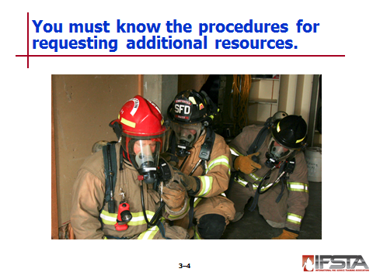
Know local procedure for requesting additional resources

Be familiar with procedures for requesting multiple or special alarm signals

Know what resources each additional alarm assignment will include – Number and types of units that respond
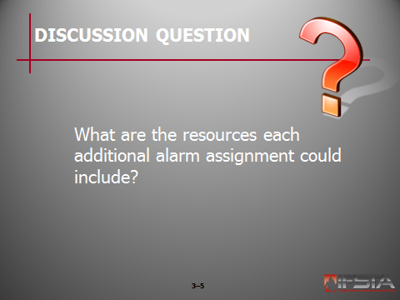
Ask Students: What are the resources each additional alarm assignment could include?
Briefly discuss answers with students. Possible answers are the number and types of units that respond to each additional alarm

Radio-equipped, mobile communications vehicle can be used at large incidents to maintain communication

Emergency Radio Traffic

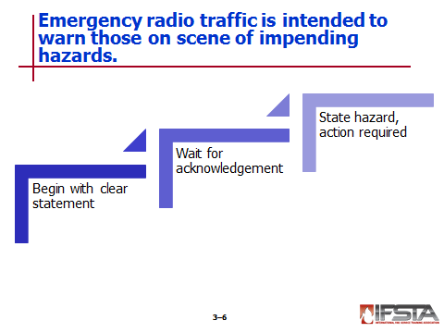
Intended to warn personnel at scene of impending hazard

Broadcast process

Begins with clear statement to alert all listeners – “Dispatch, Engine One, Emergency Traffic!”

Dispatch or IC acknowledge statement with vocal response or use of alert tone

Unit originating states type of hazard, action required – “Engine One, west wall showing signs of collapse, cease interior operations and evacuate the structure.”

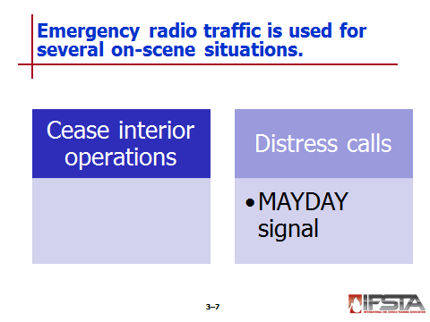
To cease interior operations

Broadcast radio message on incident’s tactical channel ordering evacuation

Sound audible warning devices on apparatus at scene

Can include distress calls from firefighters

May require use of MAYDAY signal

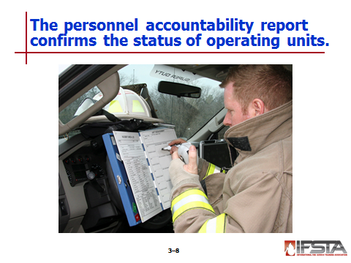
Personnel Accountability Report (PAR)

Systematic method of confirming status of units operating at incident

When requested, every supervisor must verify status of those under command and report it

Limitation — Uses a considerable amount of radio time

Reasons for request

Incident declared under control

Change from offensive to defensive strategy

Sudden catastrophic event such as flashover, backdraft, or collapse

Emergency evacuation

Firefighter reported missing or in distress

Primary search completed

Safety Officer requests it

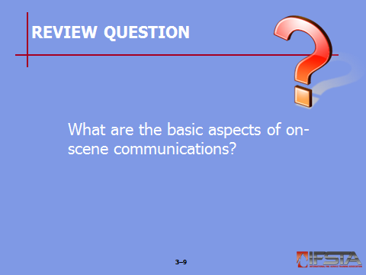
Review Question: What are the basic aspects of on-scene communications?
See page 116 of the manual for answers.

Section II: Postincident Reports

PostIncident Reports
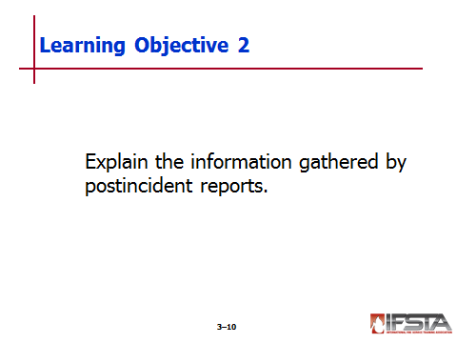
pp. 121-123 Objective 2 — Explain the information gathered by postincident reports.

Postincident Reports

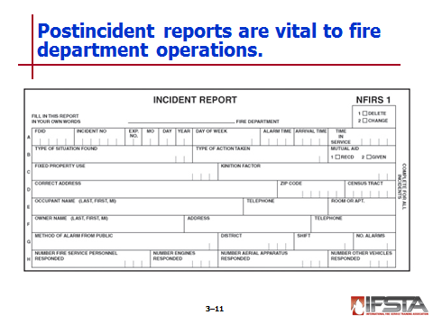
Vital to fire department operations from legal, statistical, and record-keeping standpoints

Must be complete and written in terminology that general public can understand

Can be handwritten or entered into computer
Instructor Note: This information correlates with Skill Sheet 3-II-1, found at the end of this lesson outline.

Information gathered for

Assessing departmental needs

Budgeting

Determining trends in types of responses

Determining trends in firefighter injuries

Providing information for national fire safety databases

Determining trends in fire causes

Determining requirements for fire and life safety education programs

Providing information to insurance rating agencies

Based on form or checklist that is easy to complete and thorough

National Fire Incident Reporting System (NFIRS)

Developed by United States Fire Administration (USFA)

Outlines necessary information needed to complete incident reports

Computer-based system that transfers data from each state to federal database

Developed to create data for analyses and to assist in combatting nation's fire problem

General list of information

Fire department name, incident number, district name/number, shift number, and number of alarms

Names and addresses of occupant(s) and/or owner(s)

Type of structure, primary use, construction type, and number of stories

How emergency was reported

Type of call

Action that was taken

Property use information

Number of injuries and/or fatalities

Number of personnel and type of apparatus that responded

How and where fire started

Method used to extinguish fire

Estimated cost of damage

Remarks/comments
Instructor Note: Postincident reports must be accurate, complete, and correctly compiled. Because incident reports are legal documents, there are possible legal consequences if the reports are inaccurate or incomplete.

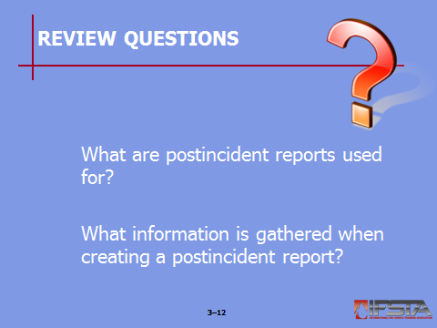
Review Questions: What are postincident reports used for?
See page 121 of the manual for answers.
What information is gathered when creating a postincident report?
See page 122 of the manual for answers.

Section III: Skill Sheet

SKILL SHEET
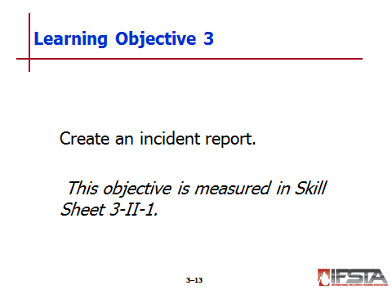
pp. 128 Objective 3 — Create an incident report.

Skill Sheet 3-II-1

For this skill sheet, students will perform the skills to create an incident report.

This skill sheet can be found in the Skill Evaluation Checklist 3-II-1 on the curriculum flash drive

This checklist corresponds with the information on p. 121-123 of the manual

Section IV: Summary and Review

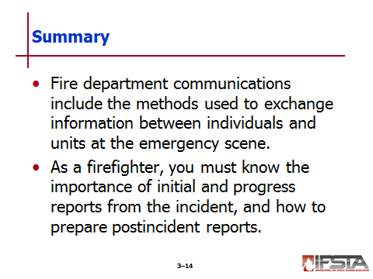
SUMMARY AND REVIEW

Chapter Summary

Fire department communications include the methods used to exchange information between individuals and units at the emergency scene.

As a firefighter, you must know the importance of initial and progress reports from the incident, and how to prepare postincident reports.

Review Questions

What are the basic aspects of on-scene communications? (116)

What are postincident reports used for? (121)

What information is gathered when creating a postincident report? (122)

