Chapter 18
Loss Control

Lesson Goal
After completing this lesson, the student shall be able to apply loss control knowledge and practices following the policies and procedures set forth by the authority having jurisdiction (AHJ).

Objectives
Upon successful completion of this lesson, the student shall be able to:
1. Explain the philosophy of loss control. [NFPA® 1001, 5.3.14]
2. Describe the ways preincident planning impacts loss control. [NFPA® 1001, 5.3.14]
3. Determine appropriate salvage procedures. [NFPA® 1001, 5.3.14]
4. Compare and contrast different types of salvage covers. [NFPA® 1001, 5.3.14]
5. Explain ways to fold, roll, spread, and improvise with salvage covers. [NFPA® 1001, 5.3.14]
6. Describe ways to cover openings during salvage operations. [NFPA® 1001, 5.3.14]
7. Explain methods used to maintain fire safety during overhaul. [NFPA® 1001, 5.3.13]
8. Describe factors that influence locating hidden fires. [NFPA® 1001, 5.3.10, 5.3.13]
9. Identify different overhaul procedures. [NFPA® 1001, 5.3.13]
10. Indicate the ways a thermal imager can be used during overhaul. [NFPA® 1001, 5.3.13]
11. Clean, inspect, and repair a salvage cover. [NFPA® 1001, 5.3.14; Skill Sheet 18-I-1]
12. Roll a salvage cover for a one-firefighter spread. [NFPA® 1001, 5.3.14; Skill Sheet 18-I-2]
13. Spread a rolled salvage cover — One-firefighter method. [NFPA® 1001, 5.3.14; Skill Sheet 18-I-3]
14. Fold a salvage cover for a one-firefighter spread. [NFPA® 1001, 5.3.14; Skill Sheet 18-I-4]
15. Spread a folded salvage cover — One-firefighter method. [NFPA® 1001, 5.3.14; Skill Sheet 18-I-5]
16. Fold a salvage cover for a two-firefighter spread. [NFPA® 1001, 5.3.14; Skill Sheet 18-I-6]
17. Spread a folded salvage cover — Two-firefighter balloon throw. [NFPA® 1001, 5.3.14; Skill Sheet 18-I-7]
18. Construct a water chute without pike poles. [NFPA® 1001, 5.3.14; Skill Sheet 18-I-8]
19. Construct a water chute with pike poles. [NFPA® 1001, 5.3.14; Skill Sheet 18-I-9]
20. Construct a catchall. [NFPA® 1001, 5.3.14; Skill Sheet 18-I-10]
21. Make a chute and attach it to a catchall. [NFPA® 1001, 5.3.14; Skill Sheet 18-I-11]
22. Locate and extinguish hidden fires. [NFPA® 1001, 5.3.10, 5.3.13; Skill Sheet 18-I-12]
Instructor Information
This is the lesson covering loss control. This lesson describes the philosophy of loss control, salvage methods and equipment, and overall procedures. The lesson also covers factors that influence locating hidden fires.

Important instructor information is provided in shaded boxes throughout the lesson plan. Carefully review the instructor information before presenting the lesson.

This lesson includes twelve skill evaluation checklist(s) that assess student ability to perform loss control. These checklists will allow students to meet the requirements of learning objectives 11-22.

Methodology
This lesson uses lecture, discussion, and skill evaluation checklists. The level of learning is application.
Outline Contents

Section | Outline Pages | Text Pages
Section I: Philosophy of Loss Control | 6 | 1104
Section II: Preincident Planning for Loss Control | 8 | 1104
Section III: Salvage | 11 | 1106
Section IV: Overhaul | 31 | 1118
Section V: Skill Sheets | 47 | 1125
Section VI: Summary and Review | 53 | 1124

Audiovisuals
- Visuals 18.1 to 18.77 (PowerPoint® Presentation)
Evaluation
- Chapter 18 Quiz
- Chapter 18 Test
- Skill Evaluation Checklists 18-I-1 to 18-I-12
Presentation Tools
Interactive Objects allow instructors to present information a piece at a time by clicking on hot spots in a larger image.

Each object is labeled in the Lesson Outline and indicated in the PowerPoint® presentation by a RED arrow in the top left corner of the image. This lets instructors know to use the mouse to explore all of the information on the slide.


After all of the information is displayed a reset arrow will appear in the bottom right corner of the image. Instructors can use this to remove the text and quiz students on content just covered or simply move on to the next slide.

To move to the slide after an interactive object, select the Click for next slide arrow on the left side of the slide.

Videos are used as discussion starters or to illustrate a concept or process discussed in the chapter.

These are labeled in the Lesson Outline and indicated in the PowerPoint® presentation by the Click image to play arrow on the left side of the slide.

Section I: Philosophy of Loss Control

Philosophy of loss control
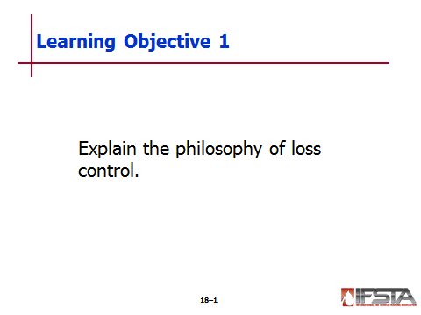
pp. 1104 Objective 1 — Explain the philosophy of loss control.

Philosophy of Loss Control

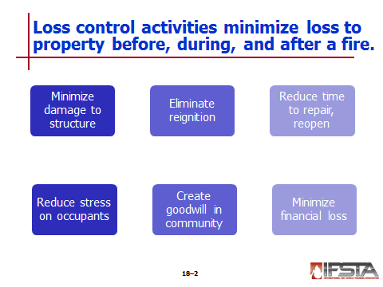
Describes activities performed to minimize losses to property – Done before, during and after fire

Is sign of professionalism; exhibits good customer service

Properly applied activities include

Minimizing damage to structure, exposures, contents

Eliminating chance fire will reignite in structure

Reducing time needed to repair, reopen the business

Reducing stress on owner/occupants of structure

Creating goodwill for fire department within community

Minimizing financial loss for owner, occupant, insurance company, community

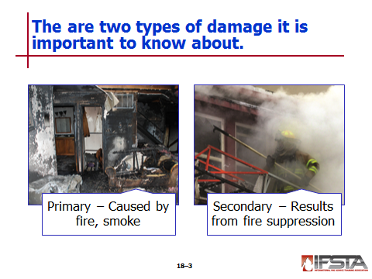
Types of damage

Primary damage – Caused by fire and smoke

Secondary damage — Results from fire suppression activities

Forcible entry, ventilation, fire extinguishment operations

Vulnerability to weather and vandalism following fire suppression

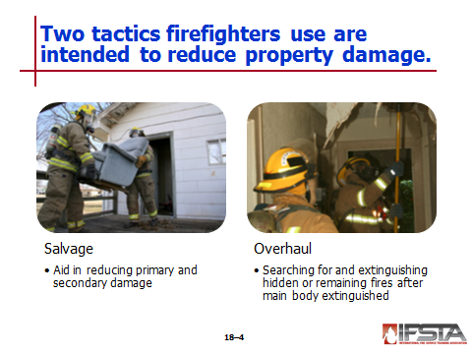
Tactics intended to reduce property damage

Salvage – Operations associated with firefighting that aid in reducing primary and secondary damage

Overhaul – Operations in searching for and extinguishing hidden or remaining fires after main body of fire extinguished
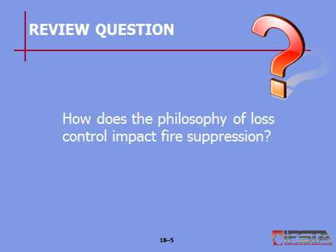
Review Question: How does the philosophy of loss control impact fire suppression?
See page 1104 of the manual for answers.

Section II: Preincident Planning for Loss Control

Preincident Planning for Loss Control
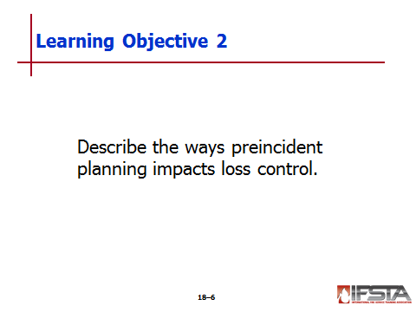
pp. 1104-1106 Objective 2 — Describe the ways preincident planning impacts loss control.

Preincident Planning for Loss Control

Special loss control-related concerns identified and addressed

May not be your responsibility to develop – May be required to implement as directed by Incident Commander (IC)

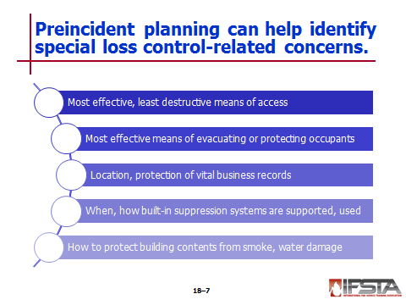
Concerns to be identified in preincident plan

Most effective, least destructive means of gaining structure access

Most effective means of evacuating or protecting building occupants during fire

Location of vital business records in structure, how to best protect them

When and how built-in fire suppression systems are to be supported, used

How building contents are to be protected from smoke, water damage

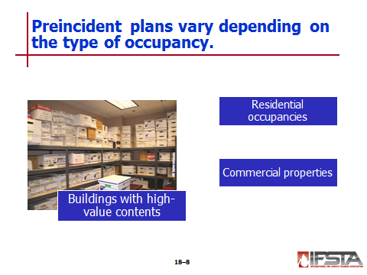
Develop special preincident plans for buildings with high-value contents – Especially susceptible to water, smoke damage

Electronic equipment

Computer systems

Artwork

Documents

Other

Preincident plans for residential occupancies include

Covering upholstered furniture, bedding, and other water-absorbent objects

Protecting items of monetary, sentimental value

Photographs

Important documents

Computer equipment

Artwork

Protect items by

Covering

Moving to unaffected area

Removing from structure

Preincident plans for commercial properties

Should reflect awareness of value to contents vital to business survival – Business owner or representative resource when determining vital items

Interacting with business owner or representative is good opportunity to recommend continual loss control practices
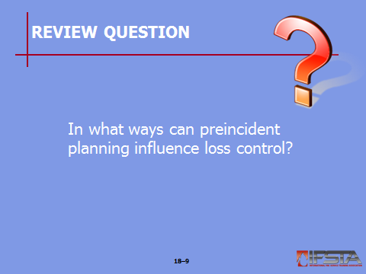
Review Question: In what ways can preincident planning influence loss control?
See pages 1104-1106 of the manual for answers.

Section III: Salvage

SALVAGE
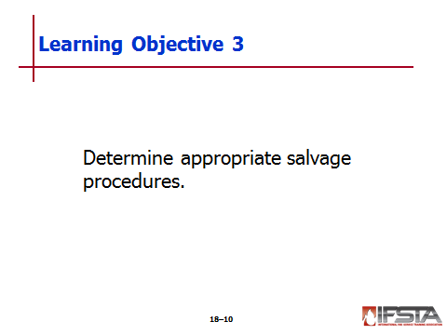
pp. 1106-1112 Objective 3 — Determine appropriate salvage procedures.
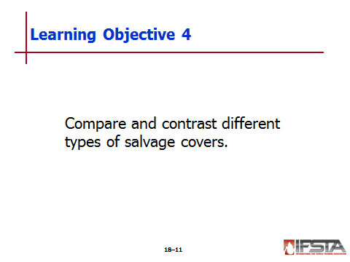
Objective 4 — Compare and contrast different types of salvage covers.

Salvage Procedures

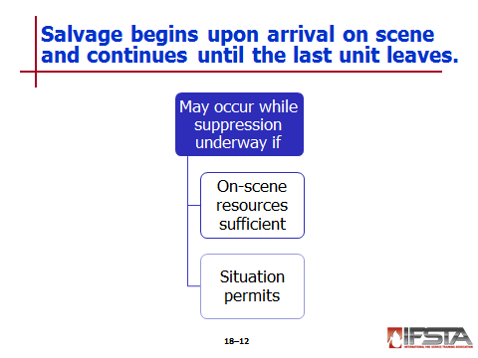
Begin upon arrival, continues until last unit leaves scene

IC may order salvage operations conducted while suppression activities underway if

On-scene resources are sufficient

Situation permits

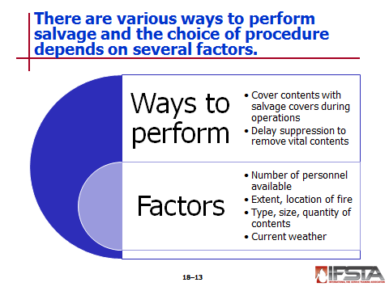
Various ways to perform

Contents of room(s) immediately below fire floor protected with salvage covers while fire suppression operations conducted

Delay suppression activities for short time to remove vital contents – IC should make decisions about delay

Choice of salvage procedures depends on

Number of personnel available

Extent, location of fire

Type, size, quantity of contents

Current weather conditions

Salvage procedures include

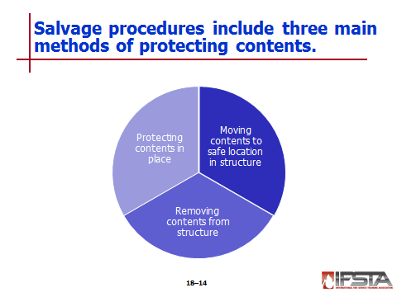
Moving contents to a safe location in structure

Should be to areas

Not in danger of fire extension

Away from concentrations of smoke

Where water will not spread

Best used when

Fire is limited

Fire not likely to spread

Weather conditions would damage contents if moved outside

May be necessary to cover contents with salvage covers or raise off floor

Removing contents from structure

Help protect them from further primary, potential secondary damage

May interfere with suppression and ventilation crews using same doors to enter structure

Contents should

Be stacked on dry surfaces not near where firefighters may be collecting debris for disposal

Be protected from theft, vandalism once fire is extinguished

Owner/occupant must be made aware contents have been stored outside or contents should be secured

Protecting contents in place – Method most often used

Contents gathered into compact piles that can be covered with minimal salvage covers

Allows more items to be protected than if covered in original position

If possible, group household furnishings in center of room

In many cases one salvage cover can protect contents of one residential room

If floor covering is removable rug, slip out from under furniture as each piece moved, roll up to move

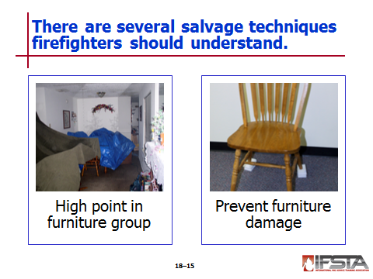
Creating one high point in furniture group

Place dresser, chest or high object at end of bed; grouping other furniture close by

Allows water to run off without collecting in depressions

Pictures, curtains, lamps, clothing, other fragile items can be placed on bed

May need to place salvage cover over bed before putting articles on bed

Preventing furniture damage – Sitting on wet carpet can cause to absorb water

Raise furniture off wet floor with water-resistant materials

Use precut plastic, foam blocks – May improvise with canned goods from kitchen

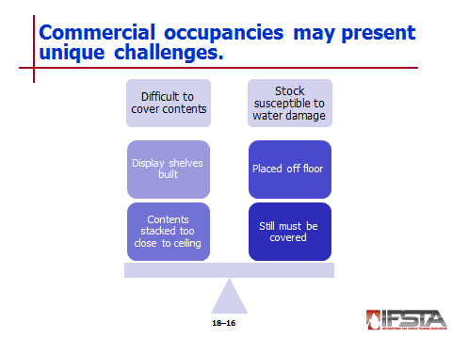
Commercial occupancies present challenges

May be difficult to cover contents when large stocks, display features involved

Display shelves frequently built to ceiling, directly against walls

Makes contents difficult to cover

Water flows down wall, comes into contact with shelving, wetting contents

Contents stacked too close to ceiling

Stock susceptible to water damage

Should be placed off floor to prevent saturation – Use of skids or pallets common, if available

Even off floor, still must be covered

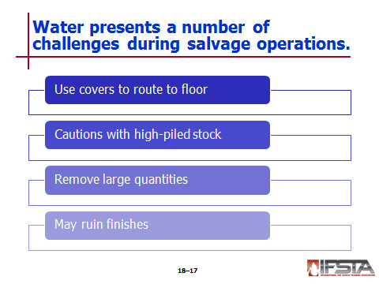
Use available covers for water chutes, catchalls

Number of salvage covers may be limited

Water must be routed to floor to be removed later

Extreme caution must be used with high-piled stock

Wetness often causes material to expand, pushing out interior or exterior walls

Wetness reduces strength of material; may cause pile to collapse

Removing large quantities of water

Locating and cleaning clogged drains

Removing toilet fixtures

Creating scuppers

Using existing sanitary piping systems

Creating chutes made of salvage covers, plastic, other available materials to route water to other areas

Water left on cabinets, other horizontal surfaces may ruin finishes – Wipe with disposable paper towels to guard against potential loss
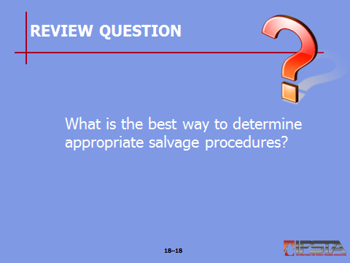
Review Question: What is the best way to determine appropriate salvage procedures?
See pages 1106-1109 of the manual for answers.

Salvage Covers and Equipment

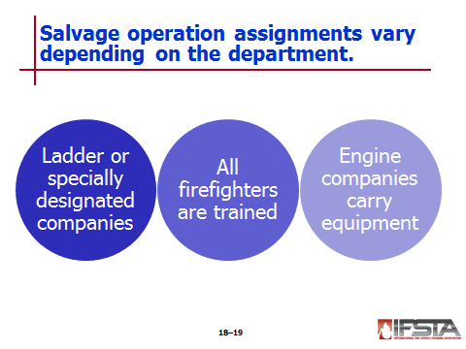
Depending on size and organization of fire department, salvage operations

Generally assigned to ladder companies and specially designated salvage, overhaul companies

All firefighters trained in salvage cover and equipment use; should be familiar with all used by their department

Engine companies carry salvage covers, hand tools, buckets for salvage operations

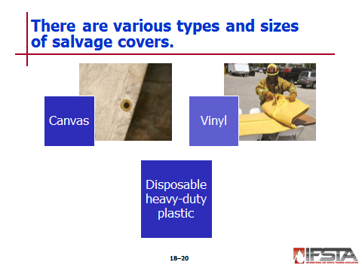
Salvage covers – Waterproof canvas or vinyl

Various sizes

Reinforced corners with edge hems, grommets for hanging or draping

Vinyl synthetic

Lightweight

Easy to handle

Economical

Indoor or outdoor use

Disposable heavy-duty plastic covers

Available on rolls

Extended as needed to cover large areas

Cut into different shapes or sizes as needed

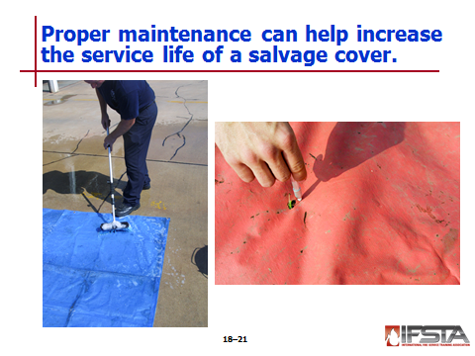
Salvage cover maintenance

Properly cleaning, drying, repairing salvage covers increases service life

Typical cleaning required for canvas

Wetting or rinsing with hose stream, scrubbing with broom

Extremely dirty, stained covers scrubbed with detergent solution, rinsed

Some foreign materials difficult to remove when allowed to dry on cover, even with detergent

Canvas should be clean, completely dry before folded, stored on apparatus – Essential to prevent mildew, rot

Permitting canvas salvage covers to dry when dirty not good as carbon and ash stains can rot canvas – Acceptable to dry outdoors but avoid when windy
Instructor Note: This information correlates with Skill Sheet 18-I-1, found at the end of this lesson outline.

NOTE: Long-term exposure of canvas to sunlight will result in damage from ultraviolet rays. Drying in direct sunlight may degrade the material over time.

Synthetic covers do not require as much maintenance as canvas covers – May be folded when wet but let dry so will not mildew

After covers are dry, should be examined for damage

To inspect for holes, three or four firefighters stand side-by-side along one end of cover

Firefighters pick up end, pass it back over heads while walking toward other end, looking at underside for light showing through even smallest holes

Mark any holes using

Chalk for canvas covers

Marking pen for vinyl covers

Firefighters place duct tape or mastic tape over holes or patch with iron-on or sew-on patches

Salvage equipment

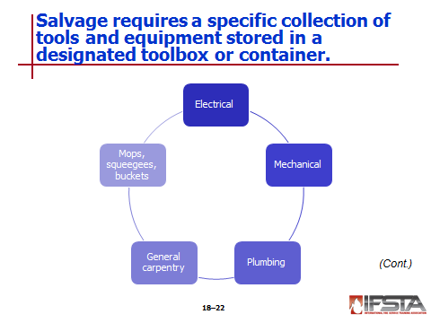
Requires specific collection of tools, equipment stored in specially designated toolbox or containers for ease of carrying

May be kept in plastic tub, brought into structure

Provides a useful water-resistant container to protect items

Typical tools, equipment used include

Electrical

Mechanical

Plumbing

General carpentry tools

Mops, squeegees, buckets – Useful for removing water

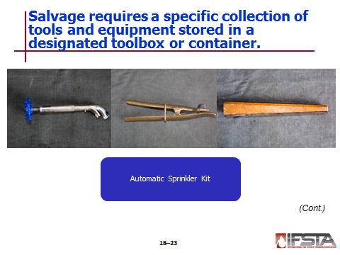
Automatic sprinkler kit – Tools used to stop flow of water from an open sprinkler

Flow of water from open sprinkler can do considerable damage to merchandise on lower floors after fire controlled in commercial building

Suggested tools for kit: sprinkler tongs or stoppers, wooden sprinkler wedges
Instructor Note: Discuss “Routing Water Out of a Sprinklered Building” on page 1111 of manual.
Discuss how and why it is important to route water out of a sprinklered building.

NOTE: Responsibility for restoring automatic sprinkler systems to service is determined by the authority having jurisdiction. You may only restore systems if you are authorized and trained to do so.

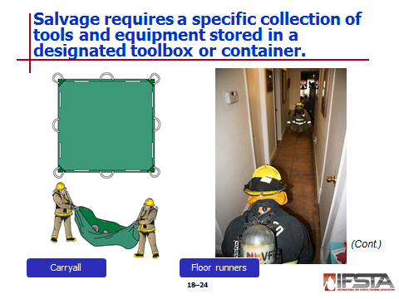
Carryalls

Used to carry debris

Catch falling debris

Provide water basin for immersing small burning objects

Constructed of nonflammable material

Floor runners – Firefighters often unintentionally damage flooring with their boots and equipment during fire suppression operations

Floor coverings protected by floor runners

Can be unrolled from entrance to almost any part of building

Commercially prepared vinyl-laminated nylon floor runners – Lightweight, flexible, tough, heat and water resistant, easy to maintain

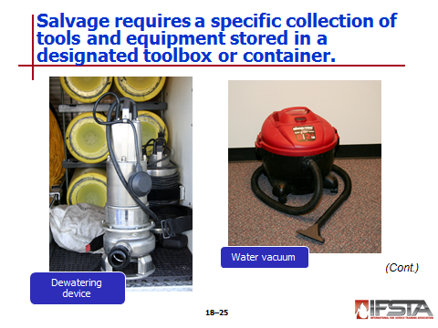
Dewatering devices – Pumps to remove water from basements, elevator shafts, sumps

Portable pumps capable of passing grey water with debris, jet-siphons, submersible pumps best suited

Can be moved to any point where line of hose placed and outlet for water provided

Water vacuum – One of easiest, fastest ways to remove water

Used to dewater floors, carpets, other areas where water is not deep enough to be picked up by submersible pump or siphon ejector

Consists of tank (worn on the back or placed on wheels) and nozzle

Backpack-type tanks normally have capacity of 4 to 5 gallons (15 L to 20 L); can be emptied by pulling lanyard to empty water through nozzle or separate drain hose

Floor models on rollers may have capacities up to 20 gallons (80 L)

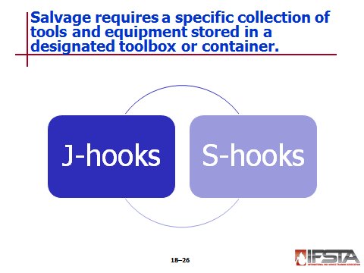
J-hooks – Designed to be driven into walls or wooden framing to provide strong point to hang objects; most often used to hang salvage covers on walls to protect wall-mounted book cases, shelving units

S-hooks – Used for same purpose as J-hooks but cannot be driven into walls or framing – Must have horizontal ledge from which to hang
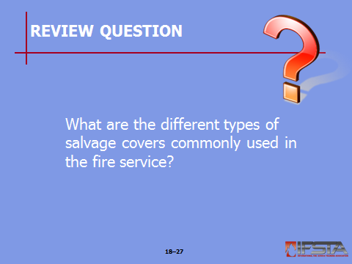
Review Question: What are the different types of salvage covers commonly used in the fire service?
See page 1109 of the manual for answers.

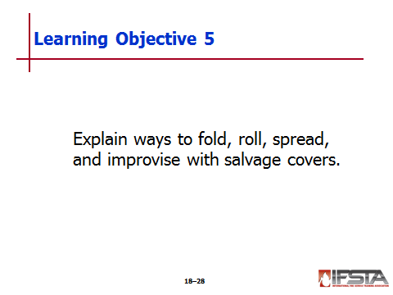
pp. 1112-1116 Objective 5 – Explain ways to fold, roll, spread, and improvise with salvage covers.
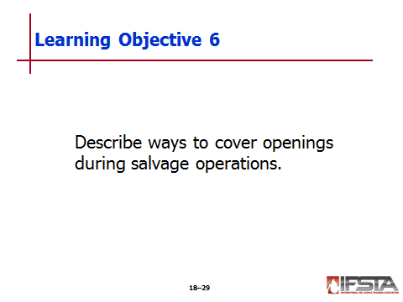
Objective 6 – Describe ways to cover openings during salvage operations.

Folding/Rolling and Spreading Salvage Covers

One-firefighter spread with a rolled salvage cover – Main advantage is one person can quickly unroll salvage cover across top of an object; may be carried on shoulder or under the arm
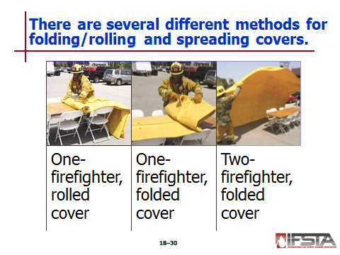
Instructor Note: This information correlates with Skill Sheet 18-I-2, found at the end of this lesson outline.

Instructor Note: This information correlates with Skill Sheet 18-I-3, found at the end of this lesson outline.

One-firefighter spread with a folded salvage cover – Some departments prefer to carry folded versus rolled salvage covers
Instructor Note: This information correlates with Skill Sheet 18-I-4, found at the end of this lesson outline.

Two firefighters are needed to make this fold, performing same functions simultaneously

Carrying folded cover on shoulder typically most convenient but any safe carrying method is acceptable
Instructor Note: This information correlates with Skill Sheet 18-I-5, found at the end of this lesson outline.

Two-firefighter spread with a folded salvage cover – Single firefighter cannot easily handle large salvage cover; should be folded for two-firefighter deployment
Instructor Note: This information correlates with Skill Sheet 18-I-6, found at the end of this lesson outline.

Most convenient way to carry fold is on shoulder with open edges next to the neck

Makes little difference which end of folded cover is placed in front of carrier as two open-end folds will be exposed

Position cover so firefighter carrying it holds lower pair of corners, second firefighter holds uppermost pair

Balloon throw most common method used for two firefighter deployment of large cover

Works best when sufficient air is pocketed under cover

Pocketed air gives a parachute effect to float cover into place over article to be covered
Instructor Note: This information correlates with Skill Sheet 18-I-7, found at the end of this lesson outline.

Improvising With Salvage Covers

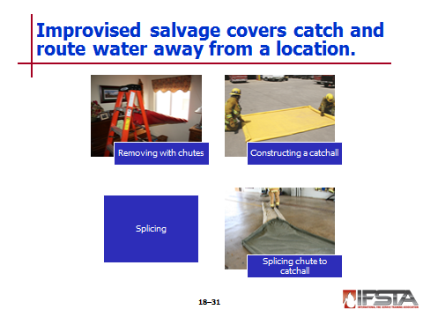
Typically used to cover building contents

Used to catch, route water from fire fighting operations or other structural flooding situations

Removing water with chutes

Water chute one of most practical methods of removing water coming through ceiling from upper floors

May be constructed on floor below fire fighting operations to drain runoff out of structure through windows or doors

Some fire departments carry prepared chutes, approximately 10 feet (3 m) long, as regular equipment; others construct chutes when, where needed using floor runners or one or more covers

Plastic sheeting, heavy-duty stapler, duct tape can be used to construct water diversion chutes
Instructor Note: This information correlates with Skill Sheets 18-I-8 and 18-I-9, found at the end of this lesson outline.

Constructing a catchall

Constructed from salvage cover

Placed on floor to hold small amounts of water

May be temporary to control large amounts of water until chutes constructed to route water outside

Can hold several hundred gallons (liters) water, saving time
Instructor Note: This information correlates with Skill Sheet 18-I-10, found at the end of this lesson outline.

To catch as much water as possible, place cover into position as soon as possible, even if sides not uniformly rolled

Two firefighters usually needed to construct

Splicing covers

Necessary to splice covers with watertight joints when

Objects or groupings too large to be covered with single cover

Long chutes or catchalls need to be made

Many methods for splicing covers – Your department will train on specific procedure

Many departments use disposable rolled plastic sheeting, cut to size as needed

Saves time and property

Eliminates need for splicing, reducing leakage risk

Splicing chute to catchall

Plan should be developed to remove water from catchall as soon as constructed, especially if volume of water greater than catchall’s capacity

Submersible pumps used if available, if significant and constant flow of water into catchall

Common water removal method is splice water chute to catchall – Advantage: as soon as water accumulates in catchall, drained to outside
Instructor Note: This information correlates with Skill Sheet 18-I-11, found at the end of this lesson outline.

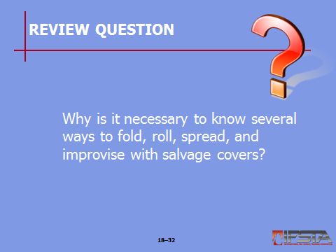
Review Question: Why is it necessary to know several ways to fold, roll, spread, and improvise with salvage covers?
See pages 1112-1116 of the manual for answers.

Covering Openings – Critical to prevent further damage by weather, trespassers

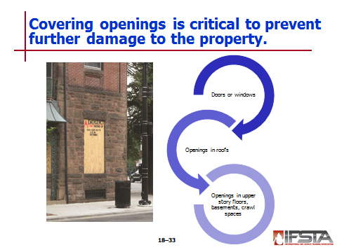
Doors or windows broken or removed should be covered

Plywood

Heavy plastic

Similar materials to keep out rain

Plywood, hinges, hasp, padlock can be used to make temporary door

Openings in roofs should be covered with plywood, roofing paper, heavy plastic sheeting, tar paper

Use appropriate roofing nails if roofing, tar paper, or plastic used

Place lath strips along edges of material, nail in place

Very important to cover openings cut in upper story floors or over basements, crawl spaces – Must be covered with lumber or thick plywood to support a person’s weight
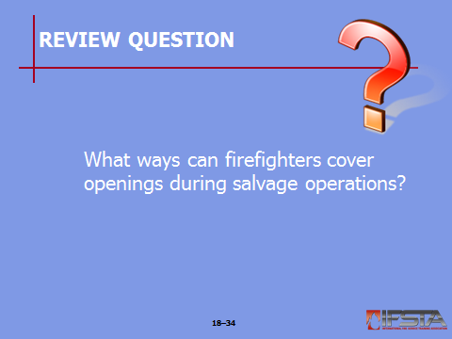
Review Question: What ways can firefighters cover openings during salvage operations?
See page 1116 of the manual for answers.

Section IV: Overhaul

OVERHAUL
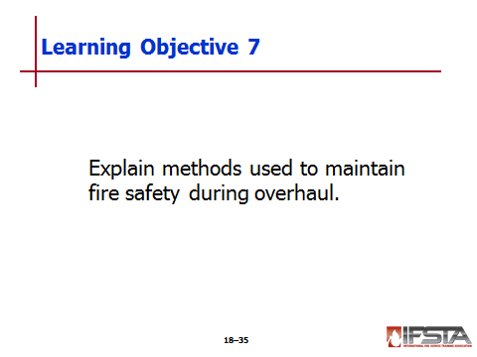
pp. 1118-1123 Objective 7 — Explain methods used to maintain fire safety during overhaul.
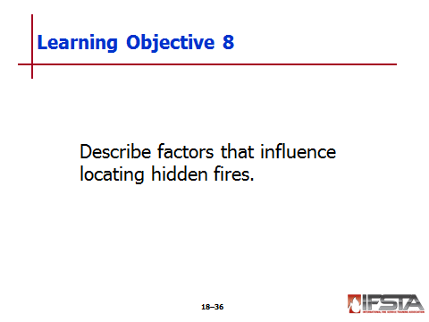
Objective 8 — Describe factors that influence locating hidden fires.
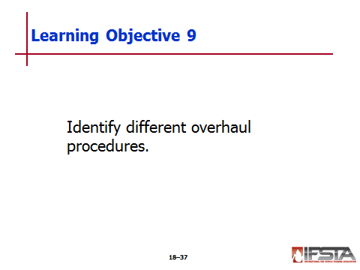
Objective 9 — Identify different overhaul procedures.
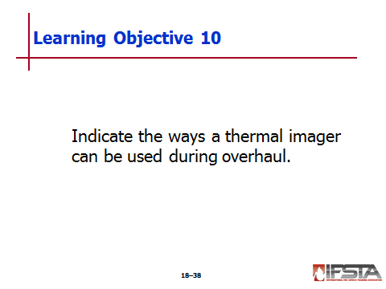
Objective 10 — Indicate the ways a thermal imager can be used during overhaul.

Overhaul

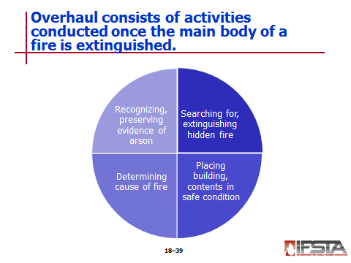
Activities conducted once main body of fire extinguished

Searching for and extinguishing hidden or remaining fire

Placing building and its contents in a safe condition

Determining cause of fire

Recognizing and preserving evidence of arson

Should begin when

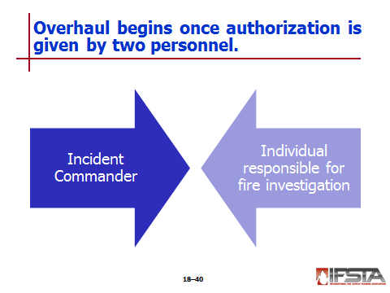
Incident Commander (IC), individual responsible for fire investigation authorize

Once order given – Firefighters attempt to put building, contents, fire area in as safe, habitable condition as possible

Salvage operations performed during firefighting affects any overhaul work that may be needed later

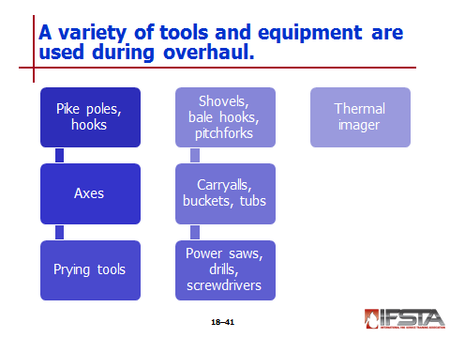
Many tools, equipment used for overhaul are same used for forcible entry, ventilation, salvage operations; may include

Pike poles, plaster hooks – Open ceilings to inspect for fire extension

Axes – Open walls, floors

Prying tools – Remove door or window frames, baseboards

Power saws, drills, screwdrivers – Install temporary doors, window coverings

Carryalls, buckets, tubs – Carry debris, provide basin for immersing smoldering material

Shovels, bale hooks, pitchforks – Move baled or loose materials

Thermal imager (TI) – Check void spaces, look for hot spots

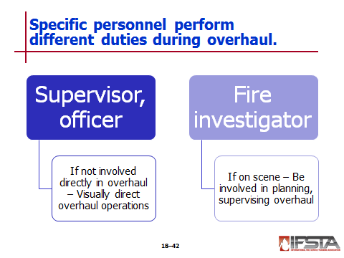
Supervisor or officer not directly engaged in overhaul should visually direct overhaul operations

If fire investigator is on scene

Should be involved in planning, supervising overhaul activities

Plans should avoid disturbing potential evidence needed to determine fire cause

Fire Safety During Overhaul

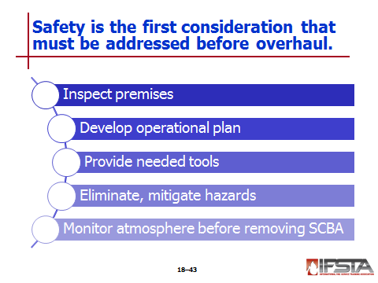
Before beginning

First consideration is safety

Plan, organize after fire brought under control

Should provide highest degree of safety to firefighters, others on scene

Steps to establish safe conditions include

Inspecting the premises

Developing an operational plan

Providing needed tools and equipment

Eliminating or mitigating hazards (including securing any remaining utilities)

Monitoring the atmosphere for carbon monoxide (CO) and hydrogen cyanide (HCN) levels before removing SCBA

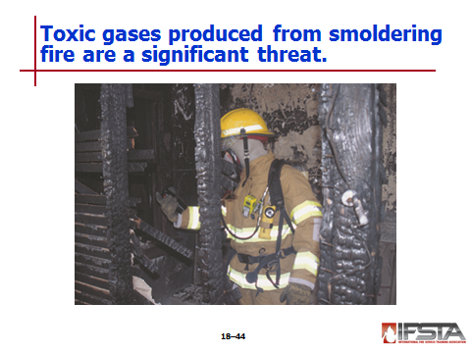
Significant threat to firefighters are toxic gases produced from smoldering fire

Even if air in structure appears to be without smoke, toxic combustion products can exist in dangerous concentrations

Carbon monoxide (CO) and hydrogen cyanide (HCN) commonly encountered toxic gases; countless others can be present depending on building contents involved in fire

Air monitoring devices should be deployed based on department’s SOPs

All personnel should continue to use SCBA until atmosphere in structure determined acceptable

Once air monitoring confirms SCBAs can be safely removed

Firefighters should wear particulate masks for protection from nontoxic, airborne particles

Property owners/occupants should not be allowed to enter structure until atmosphere deemed acceptable
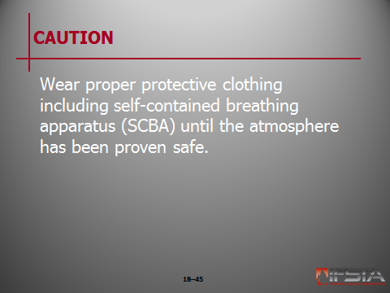
CAUTION: Wear proper protective clothing including self-contained breathing apparatus (SCBA) until the atmosphere has been proven safe.

Many other hazards exist for firefighters performing overhaul

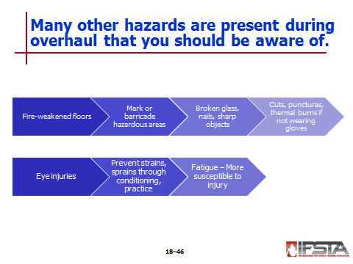
Personnel may fall, become injured when fire-weakened floors collapse or fail

Any potentially hazardous areas identified should be marked or barricaded immediately

Can also be injured by stepping on broken glass, nails, other sharp objects

Handling fire debris during overhaul – Firefighters susceptible to cuts, punctures, thermal burns if not wearing gloves

Eye protection is critical to avoid injuries to eyes

Strains, sprains prevented through physical conditioning, practicing safe lifting techniques

Preventable cause of injury is fatigue – Exhausted firefighters more susceptible to injury than those rested

Firefighters not directly involved in rescue and fire control should conduct overhaul operations if resources allow

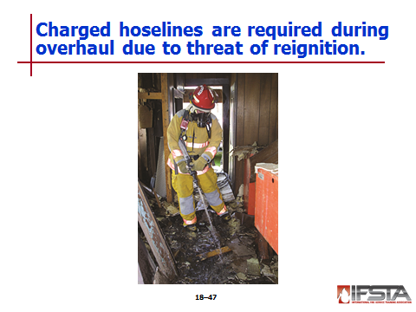
Due to threat of reignition, charged hoselines should be present during overhaul operations

1½-inch (38 mm) or 1¾-inch (45 mm) attack lines can be used

At least one attack line should be available in the event of rekindle

Regardless of type of hose used, place nozzle so it will not cause additional water damage

Hoselines should be constantly monitored for leakage, especially at couplings

Using 100-foot (30 m) section of hose as first section on attack lines reduces chances any couplings other than at the nozzle would even be inside a building

To protect yourself during overhaul operations

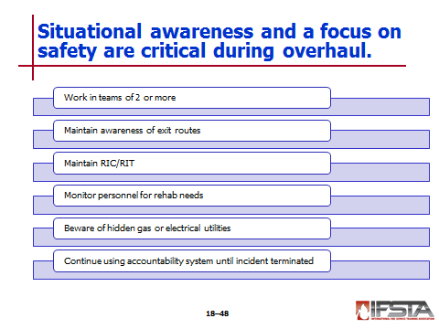
Continue to maintain situational awareness

Focus on safety

Additional safety considerations during overhaul operations

Continue to work in teams of two or more

Maintain awareness of available exit routes

Maintain rapid intervention crew or team (RIC/RIT) throughout operation

Monitor personnel for need of rehabilitation

Beware of hidden gas or electrical utilities

Continue using accountability system until incident terminated
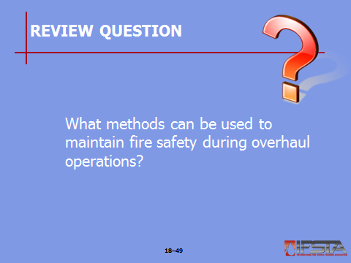
Review Question: What methods can be used to maintain fire safety during overhaul operations?
See pages 1119-1120 of the manual for answers.

Locating Hidden Fires

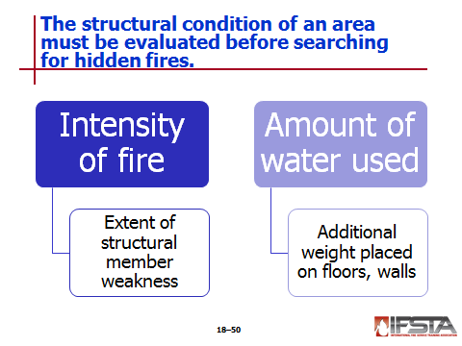
Before starting – Evaluate structural condition of area to be searched

Intensity of fire and amount of water used for control affect building condition

Intensity of fire determines extent structural members weakened

Amount of water used determines additional weight placed on floors, walls due to absorbent properties of building contents

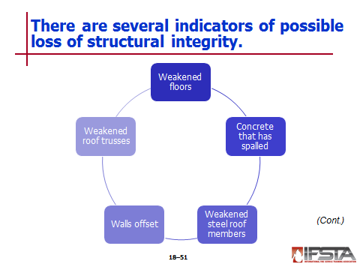
Indicators of possible loss of structural integrity

Weakened floors due to floor joists being burned away

Concrete that has spalled due to heat

Weakened steel roof members

Walls offset because of elongation of steel roof supports

Weakened roof trusses due to burn-through of key members

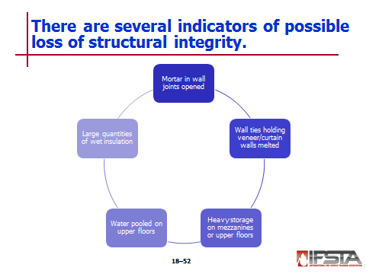
Mortar in wall joints opened due to excessive heat

Wall ties holding veneer/curtain walls melted from heat

Heavy storage on mezzanines or upper floors

Water pooled on upper floors

Large quantities of wet insulation

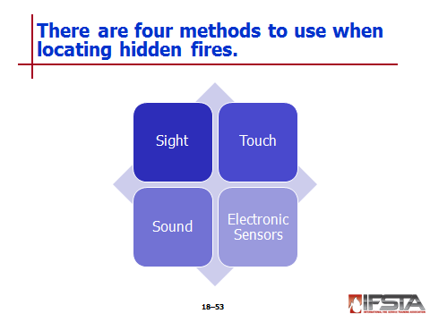
Firefighters can detect hidden fires by sight, touch, sound, electronic sensors including

Sight

Discoloration of materials

Peeling paint

Smoke emissions from cracks

Cracked plaster

Rippled wallpaper

Burned areas

Touch – Heat felt through walls and floors

Sound

Popping, cracking of fire burning

Hissing of steam

Electronic sensors

Thermal (heat) signature detection with thermal imager

Infrared heat detection
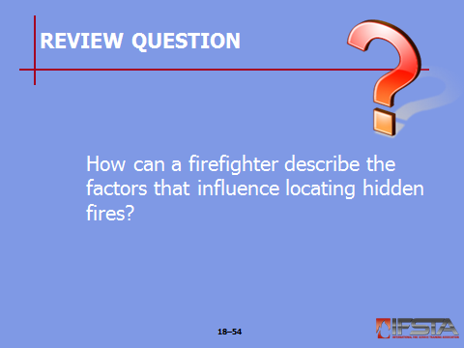
Review Question: How can a firefighter describe the factors that influence locating hidden fires?
See pages 1120-1121 of the manual for answers.

Overhaul Procedures

Overhaul typically begins in area of most severe fire involvement

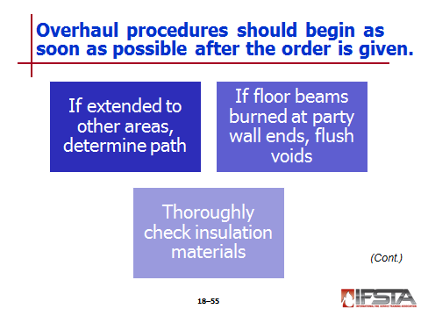
Process of looking for fire extension should begin as soon as possible after the IC gives the order

If fire has extended to other areas of structure, firefighters must determine path through which it traveled

Concealed wall spaces

Unsealed pipe chases

If floor beams burned at their ends where enter a party wall, overhaul ends by flushing voids in wall with water — Also inspect other side of wall to determine whether fire or water has come through

Thoroughly check insulation materials

Can retain hidden fires for prolonged period

Usually necessary to remove insulation material to extinguish fire in it

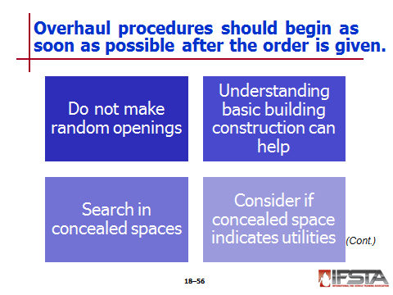
Do not start making random openings in walls or ceilings without cause – Actions must be justifiable

Understanding basic building construction concepts will help you in searching for hidden fires

If fire burned around windows or doors, pull open areas to expose inner parts of frame or casing, visually verify full extinguishment

If fire burned around combustible roof or cornice, advisable to open cornice to inspect for hidden fires

In structures using balloon construction, check attic and basement for fire extension
Instructor Note: Remind students about the information in Chapter 4 concerning building construction. Note that understanding basic building construction will help in searching for hidden fires.

Often necessary to search for hidden fires in concealed spaces below floors, above ceilings, within walls and partitions

First move furnishings of room to locations where will not be damaged – If not possible, protect with salvage covers

Remove only enough wall, ceiling, floor covering to verify complete extinguishment

Weight-bearing members should not be disturbed

Inspect wall openings for possible fire extension into wall cavity

Electrical receptacles and switches

Return air ducts

Heating vents

Telephone and cable connections

Walls, ceilings in kitchens, bathrooms, utility rooms contain ventilation fans, pipes, ducts, other passages that will permit fire to extend — If these rooms show evidence of fire spread, walls and ceiling should be inspected

When opening concealed spaces, consider if space contains indicators of presence of utilities

Electrical wiring

Gas piping

Plumbing

Electrical outlets

Gas connections

Water

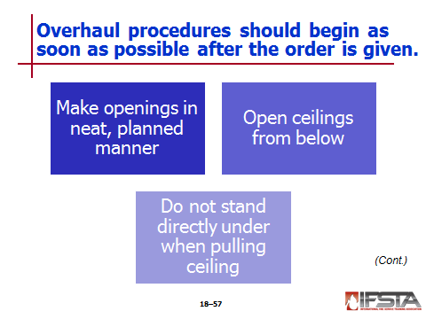
Consideration should be given to future repair of structure – Openings should be made in a neat and planned manner

Reduces the amount of work for future restoration

Sign of professionalism on part of firefighter

Ceilings may be opened from below with pike pole or appropriate overhaul tool

To open lath and plaster ceilings, break plaster first, then pull off lath – some plaster ceilings have wire mesh embedded in plaster so when start to come down, may be in one very large piece

Some newer plaster ceilings backed with gypsum wallboard instead of wooden lath

Metal or composition ceilings may be pulled from joists in similar manner

When pulling any ceiling

Do not stand directly under area to be opened – Always position yourself between area being pulled down and doorway to keep exit route from being blocked with falling debris

Always wear full PPE including respiratory protection
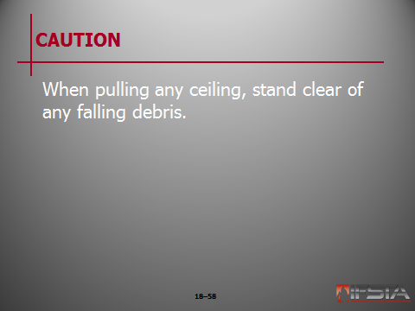
CAUTION: When pulling any ceiling, stand clear of any falling debris.

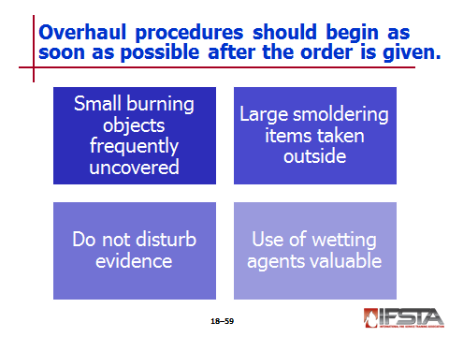
Small burning objects frequently uncovered during overhaul

Because of their size, condition, often more effective to submerge entire object in containers of water than drench with hose streams

Bathtubs

Sinks

Lavatories

Wash tubs

Large smoldering items should be taken outside structure for thorough extinguishment

Mattresses

Stuffed furniture

Bed linens

Scorched or partially burned articles can be helpful to investigator in preparing inventory or determining fire cause – firefighters need to work closely with fire investigator to ensure evidence not disturbed

Use of wetting agents such as Class A foam is valuable when extinguishing hidden fires

Penetrating qualities of wetting agents facilitate complete extinguishment in cotton, upholstery, baled goods

Only way to ensure fires in bales of items such as rags, cotton, hay extinguished is to break apart
Instructor Note: This information correlates with Skill Sheet 18-I-12, found at the end of this lesson outline.

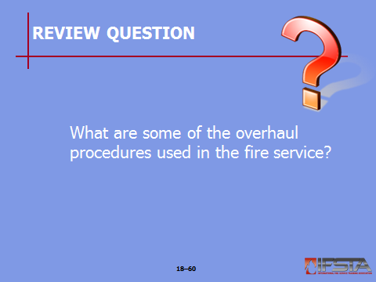
Review Question: What are some of the overhaul procedures used in the fire service?
See pages 1121-1122 of the manual for answers.

Overhaul with Thermal Imagers (TIs)

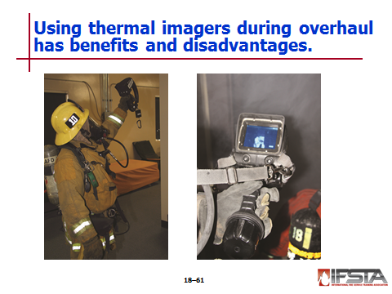
Thermal imagers (TIs) identify heat signature of items, project resulting image onto screen for firefighter to see

Use to find hidden fires in concealed spaces such as floors, ceilings, walls without having to open up areas to visually inspect

Reduces time needed to perform search and limits secondary structure damage

Because of the way TIs operate, they sometimes do not provide quality images of items behind reflective materials such as metal, mirrors, and glass – In these instances, traditional methods to reveal hidden fire should be used

While extremely useful, TIs are only tools – If there are discrepancies between TI image and signs of fire in a concealed space, space should be opened up, inspected visually
Instructor Note: Discuss Safety Alert “Thermal Imagers Must not Replace Your Senses” on page 1124 of the manual. Emphasize with students that the TI is a tool that has limitations and it should not replace their own senses and judgement.

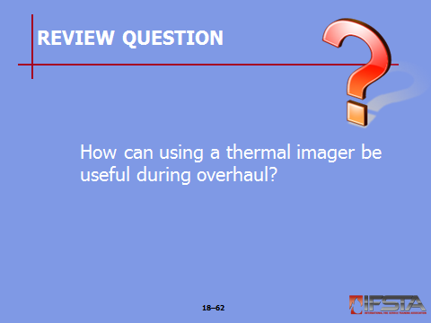
Review Question: How can using a thermal imager be useful during overhaul?
See pages 1123 of the manual for answers.

Section V: Skill Sheets

SKILL SHEETS
pp. 1125 Objective 11 — Clean, inspect, and repair a salvage cover.

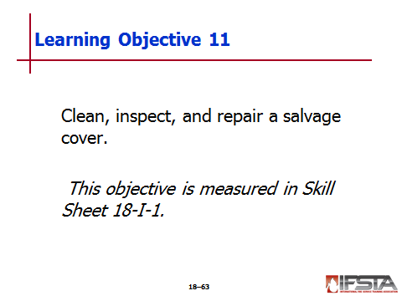
Skill Sheet 18-I-1

For this skill sheet, students will perform the skills to clean, inspect, and repair a salvage cover

This skill sheet can be found on the Skills Evaluation Checklist 18-I-1 on the curriculum flash drive

This checklist corresponds with the information on pp. 1109 of the manual

pp. 1126-1127 Objective 12 – Roll a salvage cover for a one-firefighter spread.

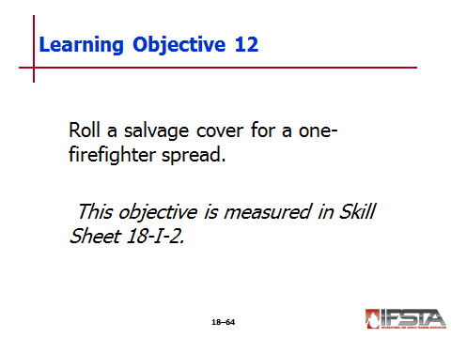
Skill Sheet 18-I-2

For this skill sheet, students will perform the skills to roll a salvage cover for a one-firefighter spread

This skill sheet can be found on the Skills Evaluation Checklist 18-I-2 on the curriculum flash drive

This checklist corresponds with the information on pp. 1113 of the manual
pp. 1128 Objective 13 – Spread a rolled salvage cover – One-firefighter method

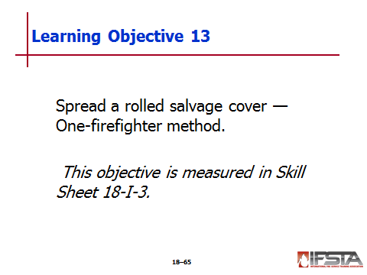
Skill Sheet 18-I-3

For this skill sheet, students will perform the skills to spread a rolled salvage cover — One-firefighter method

This skill sheet can be found on the Skills Evaluation Checklist 18-I-3 on the curriculum flash drive

This checklist corresponds with the information on pp. 1113 of the manual
pp. 1129-1130 Objective 14 – Fold a salvage cover for a one-firefighter spread.

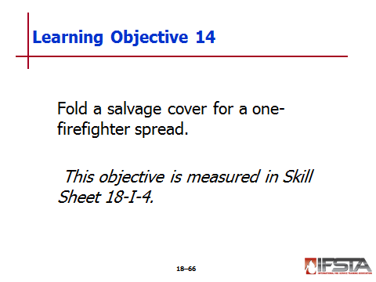
Skill Sheet 18-I-4

For this skill sheet, students will perform the skills to fold a salvage cover for a one-firefighter spread

This skill sheet can be found on the Skills Evaluation Checklist 18-I-4 on the curriculum flash drive

This checklist corresponds with the information on pp. 1113 of the manual
pp. 1131 Objective 15 – Spread a folded salvage cover – One-firefighter method.

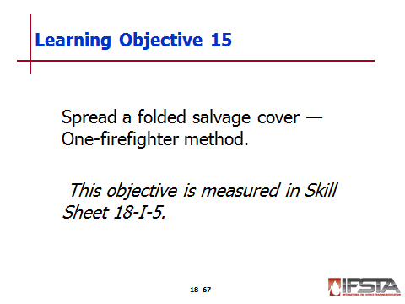
Skill Sheet 18-I-5

For this skill sheet, students will perform the skills to spread a folded salvage cover – One-firefighter method

This skill sheet can be found on the Skills Evaluation Checklist 18-I-5 on the curriculum flash drive

This checklist corresponds with the information on pp. 1113 of the manual
pp. 1132-1133 Objective 16 – Fold a salvage cover for a two-firefighter spread.

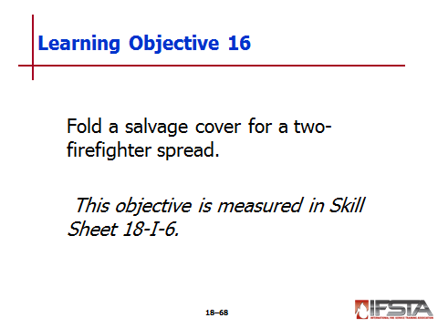
Skill Sheet 18-I-6

For this skill sheet, students will perform the skills to fold a salvage cover for a two-firefighter spread

This skill sheet can be found on the Skills Evaluation Checklist 18-I-6 on the curriculum flash drive

This checklist corresponds with the information on pp. 1114 of the manual
pp. 1134 Objective 17 – Spread a folded salvage cover – Two-firefighter balloon throw.

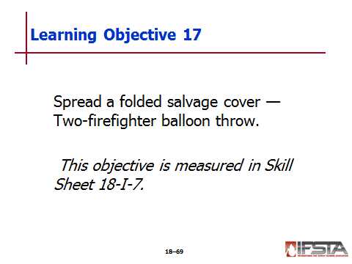
Skill Sheet 18-I-7

For this skill sheet, students will perform the skills to spread a folded salvage cover – Two-firefighter balloon throw

This skill sheet can be found on the Skills Evaluation Checklist 18-I-7 on the curriculum flash drive

This checklist corresponds with the information on pp. 1114 of the manual
pp. 1135 Objective 18 – Construct a water chute without pike poles.

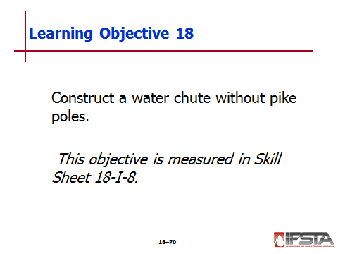
Skill Sheet 18-I-8

For this skill sheet, students will perform the skills to construct a water chute without pike poles

This skill sheet can be found on the Skills Evaluation Checklist 18-I-8 on the curriculum flash drive

This checklist corresponds with the information on pp. 1115-1116 of the manual
pp. 1136 Objective 19 – Construct a water chute with pike poles.

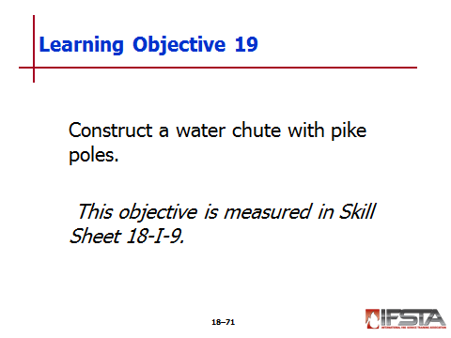
Skill Sheet 18-I-9

For this skill sheet, students will perform the skills to construct a water chute with pike poles

This skill sheet can be found on the Skills Evaluation Checklist 18-I-9 on the curriculum flash drive

This checklist corresponds with the information on pp. 1115-1116 of the manual
pp. 1137 Objective 20 – Construct a catchall.

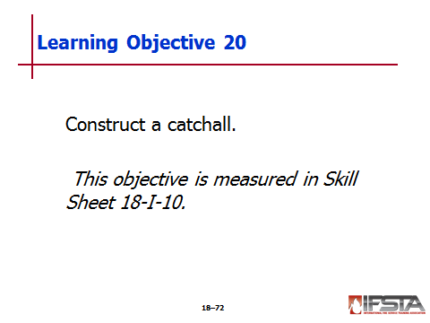
Skill Sheet 18-I-10

For this skill sheet, students will perform the skills to construct a catchall

This skill sheet can be found on the Skills Evaluation Checklist 18-I-10 on the curriculum flash drive

This checklist corresponds with the information on pp. 1116 of the manual
pp. 1138 Objective 21 – Make a chute and attach it to a catchall.

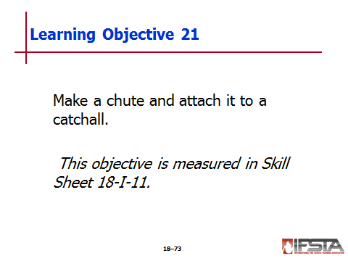
Skill Sheet 18-I-11

For this skill sheet, students will perform the skills to make a chute and attach it to a catchall

This skill sheet can be found on the Skills Evaluation Checklist 18-I-11 on the curriculum flash drive

This checklist corresponds with the information on pp. 1116 of the manual
pp. 1139-1140 Objective 22 – Locate and extinguish hidden fires.

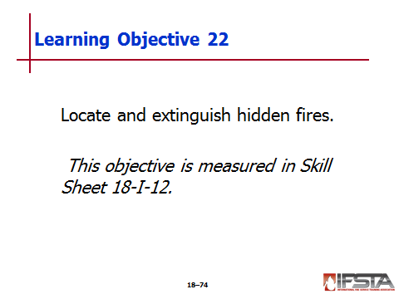
Skill Sheet 18-I-12

For this skill sheet, students will perform the skills to locate and extinguish hidden fires

This skill sheet can be found on the Skills Evaluation Checklist 18-I-12 on the curriculum flash drive

This checklist corresponds with the information on pp. 1121-1122 of the manual

Section VI: Summary and Review

Summary and review

Chapter Summary

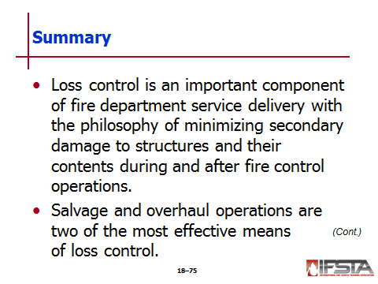
Loss control is an important component of fire department service delivery with the philosophy of minimizing secondary damage to structures and their contents during and after fire control operations.

Salvage and overhaul operations are two of the most effective means of loss control.

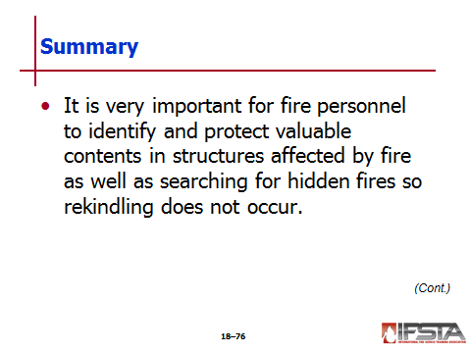
It is very important for fire personnel to identify and protect valuable contents in structures affected by fire as well as searching for hidden fires so rekindling does not occur.

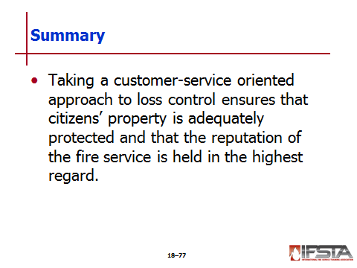
Taking a customer-service oriented approach to loss control ensures that citizens’ property is adequately protected and that the reputation of the fire service is held in the highest regard.

Review Questions

How does the philosophy of loss control impact fire suppression? (1104)

In what ways can preincident planning influence loss control? (1104-1106)

What is the best way to determine appropriate salvage procedures? (1106-1109)

What are the different types of salvage covers commonly used in the fire service? (1109)

Why is it necessary to know several ways to fold, roll, spread, and improvise with salvage covers? (1112-1116)

What ways can firefighters cover openings during salvage operations? (1116)

What methods can be used to maintain fire safety during overhaul operations? (1119-1120)

How can a firefighter describe the factors that influence locating hidden fires? (1120-1121)

What are some of the overhaul procedures used in the fire service? (1121-1122)

How can using a thermal imager be useful during overhaul? (1123)

