Chapter 5
Fire Behavior

Lesson Goal
After completing this lesson, the student shall be able to explain the science of fire behavior as it relates to recognizing stages of fire development, rapid fire behavior, and fire fighting operational safety.
Objectives
Upon successful completion of this lesson, the student shall be able to:
1. Explain the science of fire as it relates to energy, forms of ignition, and modes of combustion. [NFPA® 1001, 5.3.11]
2. Describe the impact of thermal energy on heat, temperature, and heat transfer. [NFPA® 1001, 5.3.12]
3. Recognize the physical states of fuel. [NFPA® 1001, 5.3.10]
4. Explain the relationship between oxygen and life safety. [NFPA® 1001, 5.3.11]
5. Identify the products of self-sustained chemical reactions. [NFPA® 1001, 5.3.11]
6. Explain the factors that affect fire development. [NFPA® 1001, 5.3.11]
7. Describe the stages of fire development. [NFPA® 1001, 5.3.11]
8. Recognize signs, causes, and effects of rapid fire development. [NFPA® 1001, 5.3.11]
9. Describe the methods through which fire fighting operations can influence fire behavior. [NFPA® 1001, 5.3.11, 5.3.12]

Instructor Information
This is the lesson covering fire behavior. This lesson describes the science of fire, various physical states fuel can be found in, classification of fires, and the stages of fire development. The relationship between fire behavior and fire fighting operations is also discussed.

Important instructor information is provided in shaded boxes throughout the lesson plan. Carefully review the instructor information before presenting the lesson.

Methodology
This lesson uses lecture and discussion. The level of learning is comprehension.

Table of Contents
Section | Outline Pages | Text Pages
Section I: Science of Fire | 5 | 208
Section II: Thermal Energy (Heat) | 17 | 216
Section III: Fuel | 27 | 223
Section IV: Oxygen | 34 | 231
Section V: Self-Sustained Chemical Reaction | 36 | 233
Section VI: Stages of Fire Development | 38 | 234
Section VII: Fire Behavior and Fire Fighting Operations | 59 | 250
Section VIII: Summary and Review | 64 | 254
Audiovisuals/Handouts
- Visuals 5.1 to 5.86 (PowerPoint® Presentation)
Evaluation
- Chapter 5 Quiz
- Chapter 5 Test

Instructor Tools
Interactive Objects allow instructors to present information a piece at a time by clicking on hot spots in a larger image.

Each object is labeled in the Lesson Outline and indicated in the PowerPoint® presentation by a RED arrow in the top left corner of the image. This lets instructors know to use the mouse to explore all of the information on the slide.


After all of the information is displayed a reset arrow will appear in the bottom right corner of the image. Instructors can use this to remove the text and quiz students on content just covered or simply move on to the next slide.

To move to the slide after an interactive object, select the Click for next slide arrow on the left side of the slide.

Videos are used as discussion starters or to illustrate a concept or process discussed in the chapter.


These are labeled in the Lesson Outline and indicated in the PowerPoint® presentation by the Click image to play arrow on the left side of the slide.

Section I: Science of Fire

Science of Fire
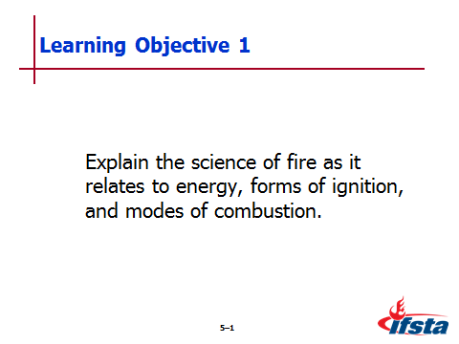
pp. 208-216 Objective 1 — Explain the science of fire as it relates to energy, forms of ignition, and modes of combustion.

Science of Fire

Fire takes variety of forms – All involve heat-producing chemical reaction between fuel and oxidizer (most common is oxygen in air)

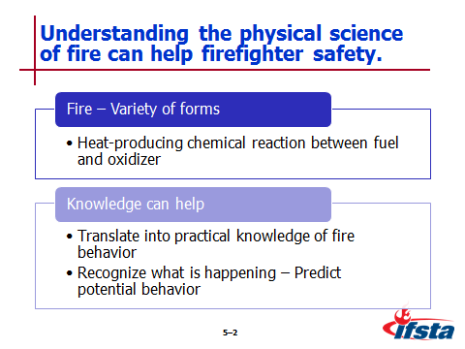
Understanding physical science of fire can help firefighter safety

Translates into practical knowledge of fire behavior

Be able to “read” the fire – Recognize what is happening, predict potential behavior

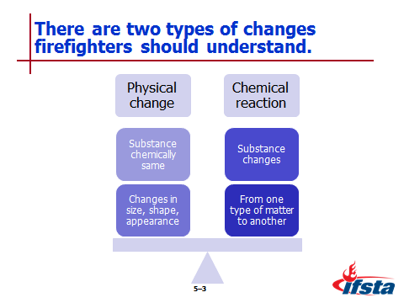
Physical change

Substance remains chemically the same, changes in size, shape, or appearance

Examples

Water freezing – Liquid to solid

Boiling – Liquid to gas

Chemical reaction

Substance changes from one type of matter into another

Examples

Two or more substances combining to form compounds

Oxidation – Combination of oxidizer with other materials; can be slow or rapid

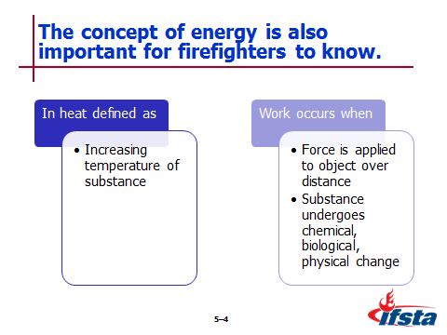
Energy

Defined as capacity to perform work

In case of heat – Defined as increasing temperature of substance

Work occurs when

Force is applied to object over distance

Substance undergoes chemical, biological, or physical change

Forms of

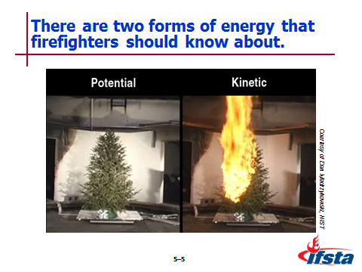
Potential

Represents amount of kinetic energy that an object can release at some point in the future

Fuels have certain amount of chemical potential energy before ignited

Different fuels release different amounts of energy over different amounts of time

Kinetic

Energy possessed by moving object

“Moving” may be on molecular level – Molecules vibrate when heat increases

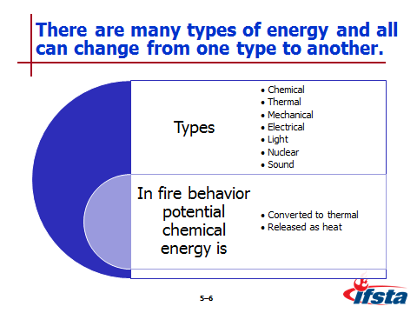
Many types

Chemical

Thermal

Mechanical

Electrical

Light

Nuclear

Sound

All energy can change from one type to another

In fire behavior – Potential chemical energy of fuel is

Converted to thermal energy

Released as heat

Measurement

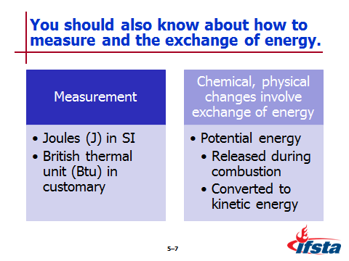
Joules (J) in International System of Units (SI)

British thermal unit (Btu) in customary system – Frequently used in fire service

1055 J = 1 Btu

Chemical, physical changes always involve exchange of energy – Fuel’s potential energy

Released during combustion

Converted to kinetic energy

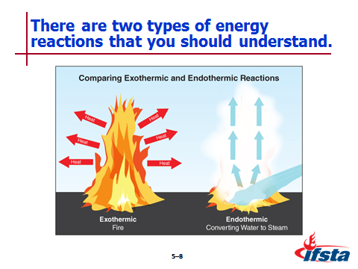
Reactions

Exothermic

Emit energy as they occur

Fire is combustion that releases energy in form of heat, sometimes visible light

Endothermic

Absorb energy as they occur

Converting water from liquid to gas requires input of energy – Important part of controlling, extinguishing some types of fires

Forms of Ignition

Process of ignition

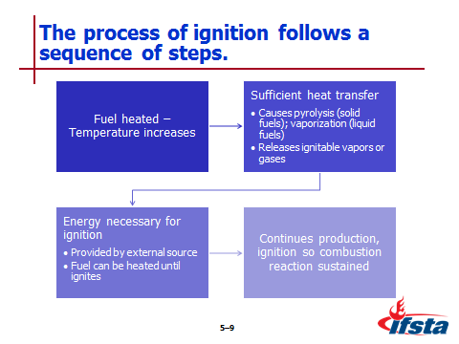
Fuel is heated – Temperature increases

Sufficient heat transfer

Causes pyrolysis in solid fuels, vaporization in liquid fuels

Releases ignitable vapors or gases

Energy necessary for ignition

Provided by external source

Fuel can be heated until ignites without spark or other source

Continues production, ignition of fuel vapors or gases so combustion reaction is sustained

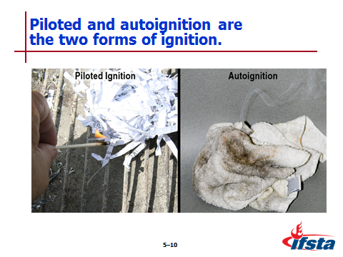
Forms of ignition

Piloted

Most common

Occurs when mixture of fuel, oxygen encounter external heat source with sufficient heat or thermal energy to start combustion process

Autoignition (nonpiloted)

Occurs without any external flame or spark to ignite fuel gases or vapors

Fuel surface is chemically heated to point at which combustion reaction occurs

Autoignition temperature (AIT) – Minimum temperature to which fuel in air must be heated to start self-sustained combustion; always higher than piloted ignition temperature

Modes of Combustion

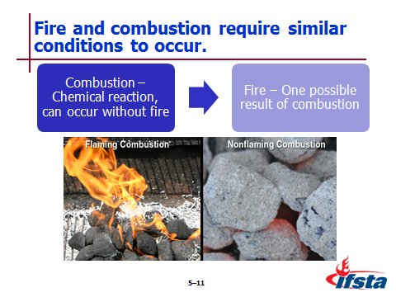
Fire, combustion similar conditions

Combustion is chemical reaction – Can occur without fire

Fire is one possible result of combustion

Two modes

Nonflaming – Occurs more slowly at lower temperature producing smoldering glow in material’s surface

Flaming – Produces visible flame above material’s surface; commonly referred to as fire

Fire Models – Explain elements of fire, how fires can be extinguished
Instructor Note: The IFSTA validation committee recommends emphasizing to students that both the fire triangle and fire tetrahedron are important fire behavior models to understand. In their opinion, the fire triangle works as an excellent introduction to the idea of the relationship between the elements needed for a fire and how removing one element can work toward extinguishing the fire. The fire tetrahedron should be explained as the industry standard for examining the chemical reaction that fire creates.

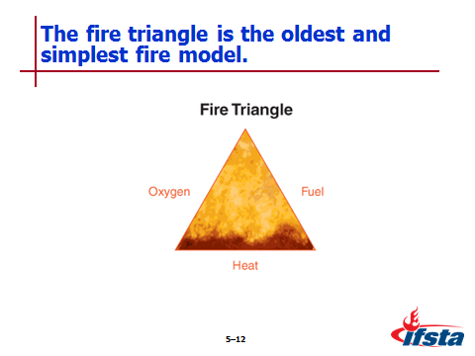
Fire triangle

Oldest, simplest model

Three elements necessary – Fuel, oxygen, heat

Remove any of elements, fire extinguished

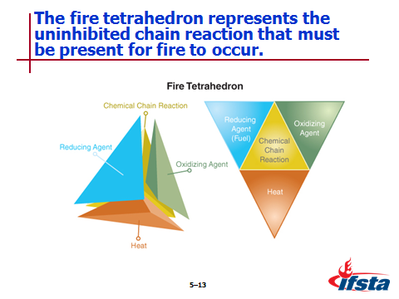
Fire tetrahedron

Uninhibited chemical chain reaction must be present for fire to occur

Created to explain fires involving certain types of substances, types of agents necessary to extinguish

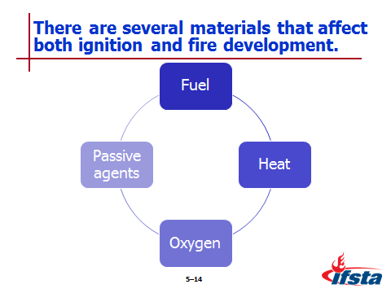
Materials that have effect on both ignition, fire development

Fuel

Heat

Oxygen

Passive agents – Materials that absorb heat but do not participate actively in combustion reaction

Drywall

Content of vegetation

Relative humidity in air outside of structures

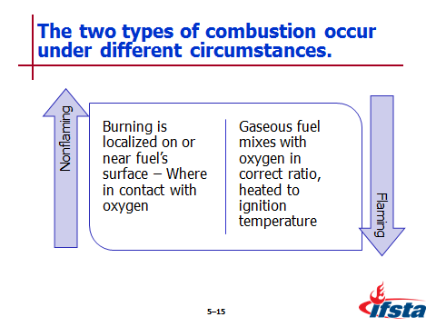
Nonflaming combustion

Occurs when burning is localized on or near fuel’s surface, where in contact with oxygen

Examples – Burning charcoal, smoldering wood or fabric

Fire triangle used to illustrate

Flaming combustion

Occurs when gaseous fuel mixes with oxygen in correct ratio, is heated to ignition temperature

Requires liquid or solid fuels to be vaporized or converted to gas phase through addition of heat

Fire tetrahedron reflect conditions required

Removing any element interrupts chemical chain reaction, stops flaming combustion

Even with elements removed – May continue to smolder

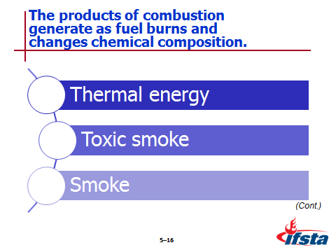
Products of combustion

Produced as fuel burns, changes chemical composition

Often described as

Heat (energy release, thermal energy)

Smoke (new substances)

Thermal energy

Heats adjacent fuels, makes them more susceptible to ignition

Causes fire spread

Without adequate protection persons may suffer from burns, damage to respiratory tract, dehydration, heat exhaustion

Toxic smoke – Causes most fire deaths

Smoke

Aerosol comprised of gases, vapor, solid particulates

Product of incomplete combustion

In structure fires multiple fuels are involved, there is limited air supply

Produces wide range of products – Toxic, flammable gases; vapors; particulates

Fire gases – Generally colorless

Vapor, particulates give smoke color

Most components toxic, present significant threat to human life – Effects result of interrelated products present
Instructor Note: Discuss the table on page 215 of the manual. Discuss the types of common products of combustion and their toxic effects with students. In the discussion be sure to review with students the SOPs departments may use to shield them from these effects.

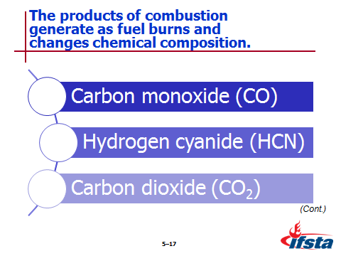
Carbon monoxide (CO)

Toxic, flammable product of incomplete combustion of organic (carbon-containing) materials

Most common product encountered in structure fires

Exposure frequently identified as cause of death for both civilians, firefighters

Acts as chemical asphyxiant – Binds with hemoglobin in blood preventing cells from distributing oxygen to body

Hydrogen cyanide (HCN)

Toxic, flammable substance produced by materials containing nitrogen

Acts as chemical asphyxiant – Prevents body from using oxygen on cellular level

Significant by-product of polyurethane foam – Commonly used in furniture, bedding

Carbon dioxide (CO₂)

Product of complete combustion of organic materials

Acts as simply asphyxiant by displacing oxygen

Acts as respiratory stimulant – Increasing respiratory rate

Irritants in smoke

Cause breathing discomfort, inflammation of eyes, respiratory tract, skin

Depends on fuels involved

Smoke may contain unburned fuel in form of solid, liquid particulates and gases

Smoke must be treated with same respect as any other flammable gas – It may burn or explode

Firefighters must use SCBA when operating in toxic atmospheres

Volume and density reduced during overhaul – But hazard not eliminated

Hazardous concentrations above published short-term exposure limits likely to be present during overhaul

Hazardous concentrations may be present in areas outside structure
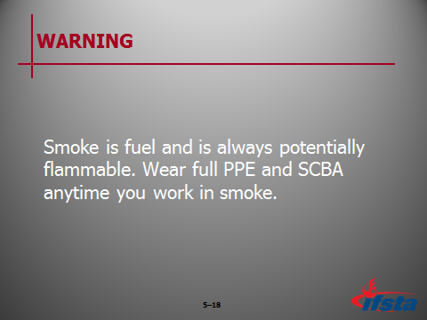
WARNING: Smoke is fuel and is always potentially flammable. Wear full PPE and SCBA anytime you work in smoke.

Flame

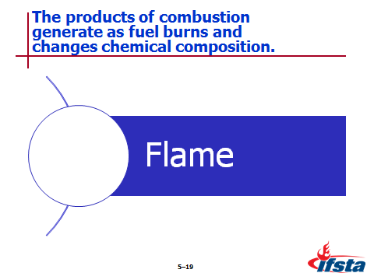
Visible, luminous body of burning gas

When mixed with proper amounts of oxygen, flame becomes hotter and less luminous

Loss of luminosity caused by more complete combustion
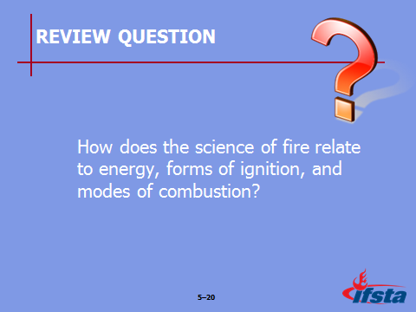
Review Question: How does the science of fire relate to energy, forms of ignition, and modes of combustion?
See pages 208-216 of the manual for answers.

Section II: Thermal Energy (Heat)

Thermal Energy (Heat)
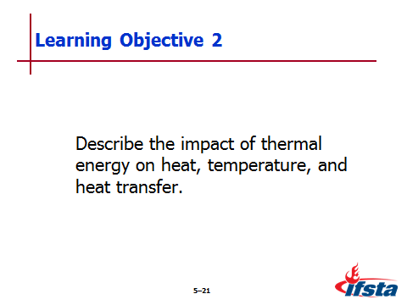
pp. 216-223 Objective 2 — Describe the impact of thermal energy on heat, temperature, and heat transfer.
  - Thermal Energy (Heat)

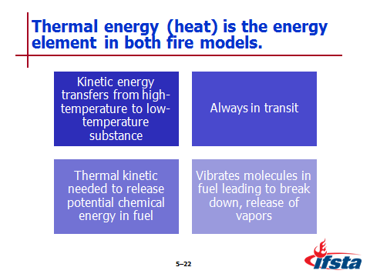
Is energy element of both fire triangle and tetrahedron

Kinetic energy transferred from high-temperature substance to low-temperature substance

Always in transit from one location to another

Thermal kinetic energy needed to release potential chemical energy in fuel

Vibrates molecules in fuel leading to their breakdown and release of vapors – Vapors can ignite, release thermal energy

Heat and Temperature

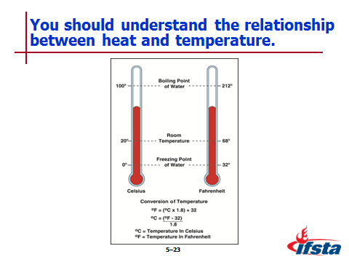
Temperature is measurement of heat – Average kinetic energy in particles of sample of matter

Scales used

Celsius – Used in metric system

Fahrenheit – Used in customary system

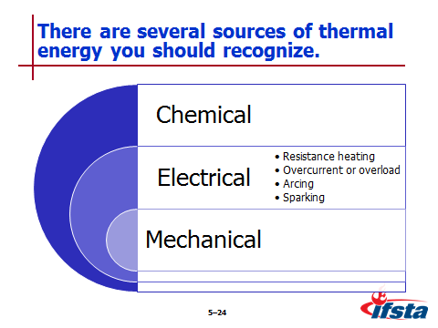
Sources of Thermal Energy

Chemical energy

Most common source of heat in combustion reactions

Potential for oxidation exists when any combustible fuel is in contact with oxygen – Process almost always results in thermal energy

Self-heating – Form of oxidation

Chemical reaction that increases temperature of material without addition of external heat

When produced slowly, energy is lost almost as fast as it is generated

May be initiated or accelerated by external heat source

Spontaneous ignition – To occur material must be heated to autoignition temperature

Insulation properties of material immediately surrounding fuel must be such that heat cannot dissipate as fast as being generated

Rate of heat production must be great enough to raise temperature of material to autoignition temperature

Available air supply in, around material being heated must be adequate to support combustion

Rate of oxidation reaction (heat production) increases as more heat is generated, trapped by insulating materials

When heat generated exceeds heat being lost, material may reach autoignition temperature

Electrical energy – Occurs in several ways

Resistance heating

When electric current flows through conductor, heat is produced

Some electrical appliances, designed to make use of resistance heating

Other electrical equipment designed to limit resistance heating under normal operating conditions

Overcurrent or overload

When current flowing through conductor exceeds design limits, may overheat and present ignition hazard

Overcurrent or overload is unintended resistance heating

Arcing

Is high-temperature luminous electric discharge across gap or through medium such as charred insulation

May be generated when conductor is separated (such as in electric motor or switch) or by high voltage, static electricity, lightning

Sparking

When electric arc occurs, luminous (glowing) particles can be formed, spatter away from point of arcing

Sparking refers to this spatter, while arc is luminous electric discharge

Mechanical energy

Generated by friction or compression

Movement of two surfaces against each other creates heat of friction – Results in heat and/or sparks

Heat of compression generated when gas is compressed

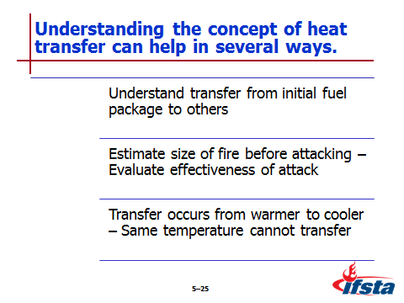
Heat Transfer

Understanding concept helps firefighters

Understand the transfer of heat from initial fuel package to other fuels in, beyond the area of origin affects growth of any fire

Use knowledge of heat transfer to estimate size of fire before attacking, to evaluate effectiveness of attack

Know that transfer occurs from warmer to cooler objects – Objects at same temperature cannot transfer heat

Transfer rate

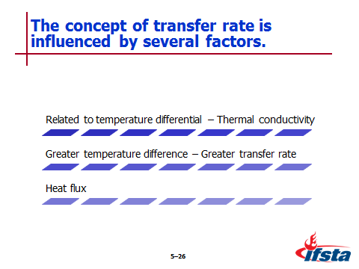
Related to temperature differential of bodies, thermal conductivity of solid material involved

Greater the temperature differences between bodies, greater transfer rate

Heat flux

Energy transfer over time per unit of surface area

Measured in kilowatts per meter squared (kW/m²)
Instructor Note: Point out the Safety Alert on page 220 of the manual. Discuss what these studies can mean to firefighters wearing PPE. Emphasize that being aware of the condition of your PPE is an important part of situational awareness.

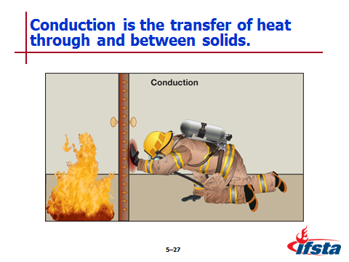
Conduction

Transfer of heat through and between solids

Occurs when material is heated as result of direct contact with heat source

Results from increased molecular motion; collisions between molecules of substance resulting in transfer of energy through substance

More tightly packed molecules are, more readily substance will conduct heat

Dependent on

Area being heated

Temperature difference between heat source and material being heated

Thermal conductivity of heated material
Instructor Note: Point out Table 5.3 on page 221 of the manual. Discuss any materials commonly seen in your local jurisdiction. Emphasize how knowing about conductivity can help firefighters during emergency scene operations.

Insulating materials slow conduction of heat

Disrupt point-to-point transfer of heat or thermal energy

Best used in building construction are made of fine particles, fibers with void spaces filled with gas – Gases do not conduct heat well

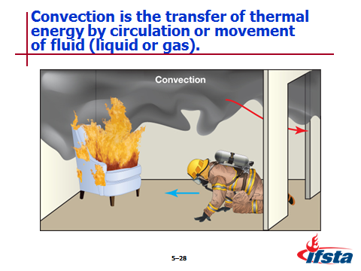
Convection

Transfer of thermal energy by circulation or movement of fluid (liquid or gas)

Usually through movement of hot smoke, fire gases in fire environment

May occur in any direction – Generally upward because smoke, fire gases are buoyant

Can move laterally

Result of differences in pressure

Move from areas of high pressure to low pressure

Can be from fire area or openings on windward side (higher pressure) to leeward side

Will feel increase in temperature when working in flow path – Energy is transferred from gas to skin
Instructor Note: One way to illustrate the concept of convection is to hold your finger in front of a blow dryer on a high heat but low blow setting. The transfer of the heat from the blow dryer to your skin illustrates how working in a flow path will increase temperatures on the fire ground.

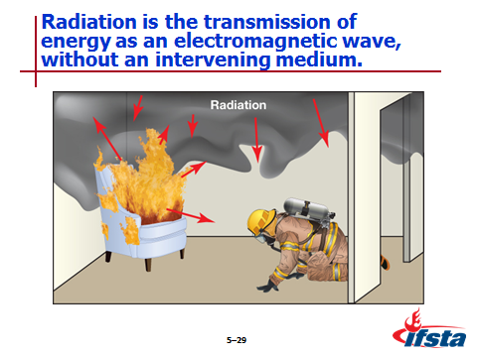
Radiation

Transmission of energy as electromagnetic wave, without intervening medium

Can become dominant mode of heat transfer when fire grows in size; may affect objects located some distance from fire

Influenced by wide range of factors

Nature of exposed surfaces

Dark materials emit, absorb heat more effectively than lighter color materials

Smooth, highly polished surfaces reflect more radiant heat than rough surfaces

Distance between heat source and exposed surfaces – Increasing distance reduces effect of radiant heat

Temperature difference between heat source and exposed surfaces

Temperature difference has major effect on heat transfer through radiation

As temperature of heat source increases, radiant energy increases by factor to fourth power

Travels in straight line at speed of light

Common cause of exposure fires – Fires ignited remote from initial origin

Travels through vacuums, air spaces where conduction, convection normally disrupted – Also disrupted by materials that reflect radiated energy

Radiant energy sources in fire

Flames have high temperature

Hot smoke in upper layer
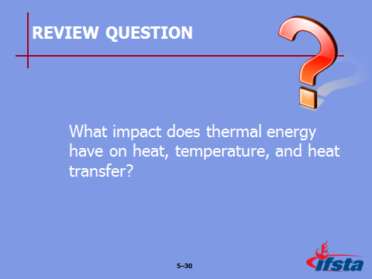
Review Question: What impact does thermal energy have on heat, temperature, and heat transfer?
See pages 216-223 of the manual for answers.

Section III: Fuel

Fuel
pp. 223-231 Objective 3 — Recognize the physical states of fuel.

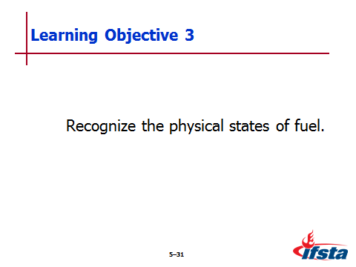
Fuel

Material or substance oxidized or burned in combustion process

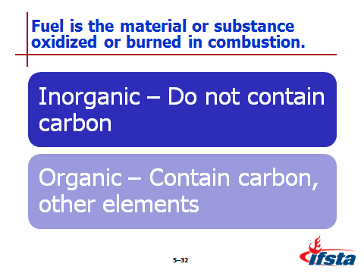
Scientifically known as reducing agent

Types

Inorganic – Do not contain carbon

Hydrogen

Magnesium

Organic – Containing carbon, other elements

Hydrocarbon-based – Gasoline, fuel, oil, plastics

Cellulose-based – Wood, paper

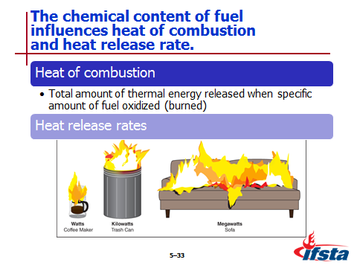
Chemical content influences

Heat of combustion

Total amount of thermal energy released when specific amount of fuel is oxidized (burned)

Usually expressed in kilojoules/gram (kJ/g)

Plastics, flammable liquids, flammable gases contain more than wood – Will be encountered in modern construction

Heat release rate (HRR)

Energy released per unit of time as fuel burns

Usually expressed in kilowatts (kW) or megawatts (MW)

Dependent on type, quantity, orientation of fuel

Directly related to oxygen consumption – Combustion process requires continuous supply to continue

Higher HHR with more available oxygen

Decreased HHR when ventilation limited

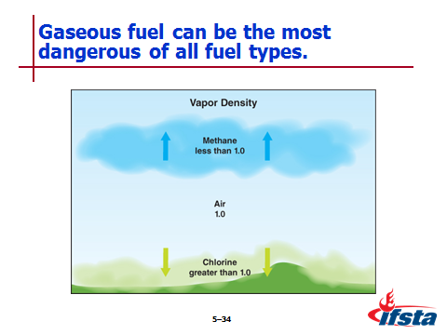
Gaseous Fuel

Can be most dangerous of all fuel types – Are already in physical state required for ignition

Vapor density

Describes density of gases in relation to air

Air assigned vapor density of 1

If gas is less than 1, will rise

If gas is greater than 1, will sink

Liquid Fuel

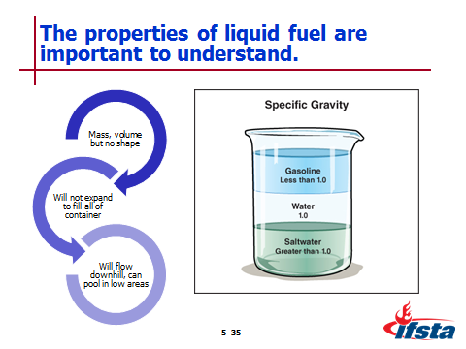
Properties

Have mass, volume but no definite shape – Except flat surface or shape of container

Will not expand to fill all of container

When released on ground, will flow downhill, can pool in low areas

Density compared to water

Specific gravity – Ratio of mass of given volume of liquid compared with mass of equal volume of water at same temperature

Water assigned specific gravity of 1

Liquids with less than 1, will float on surface

Liquids with greater than 1, will sink

Must be vaporized to burn

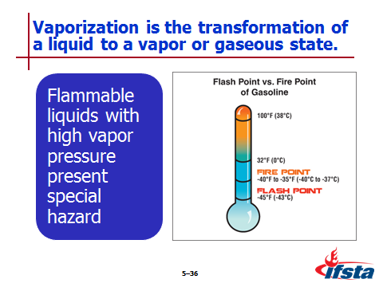
Vaporization – Transformation of liquid to vapor or gaseous state

Escaping vapors must be at higher pressure than atmospheric pressure to occur

Vapor pressure – Pressure vapors escaping from liquid exert; indicates how easily substance will evaporate or go into air

Flammable liquids with high vapor pressure present special hazard for firefighters

As liquid heats, vapor pressure increases with rate of vaporization

Volatility (ease) with which liquid gives off vapor influences how easily it can be ignited

Flash point – Minimum temperature at which liquid gives off sufficient vapors to ignite, but not sustain combustion

Fire point

Temperature at which sufficient vapors are being generated to sustain combustion reaction

Commonly used to indicate flammability hazard of liquid fuels

Extent to which liquid gives off vapor also influenced by how much surface area is exposed to atmosphere

Solubility

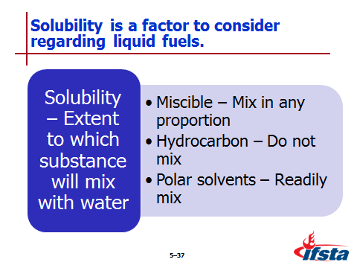
Extent to which substance will mix with water

Expressed in qualitative terms or as percentage

Miscible materials – Mix in any proportion

Hydrocarbon fuels – Do not mix

Polar solvents – Readily mix

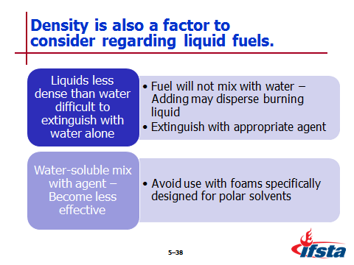
Liquids less dense than water difficult to extinguish using water as only extinguishing agent

Fuel will not mix with water, adding water may disperse burning liquid instead of extinguishing; potentially spreading fire

Should be extinguished with appropriate foam, chemical agent

Water-soluble liquids will mix with agent, become less effective at extinguishing fire – To avoid use foams specifically designed for polar solvents

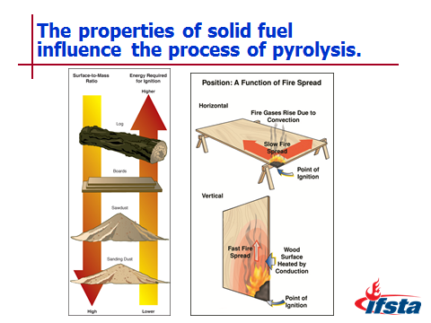
Solid Fuel

Properties

Have definite size, shape

May react differently when exposed to heat; some readily melt, others do not

When heated – Decompose, release fuel gases, vapors

Pyrolysis – Chemical decomposition of substance through action of heat

Can generate sufficient quantities of burnable vapors to ignite in presence of sufficient oxidizer

Must occur to generate flammable vapors required for combustion

Begins in wood at temperatures below 400°F (204°C)

Occurs much sooner in plastics – No moisture to slow process
Instructor Note: Discuss the table on page 229 of the manual. Discuss the effects of pyrolysis within the temperature zone of your jurisdiction. Emphasize with students how to remain aware of the impact of seasonal changes on these effects.

Primary consideration for ignition is surface area of fuel in proportion to mass – Called surface-to-mass ratio

Example
Instructor Note: Discuss the example of surface-to-mass ratio changes in a large tree provided on page 230 of the manual. Emphasize with students how this concept impacts combustion rates.

As surface-to-mass ratio increases – Fuel particles become smaller

As surface area increases, more material is exposed to heat, generates combustible pyrolysis products more quickly

Proximity, orientation of solid fuel relative to source of heat also affects way it burns
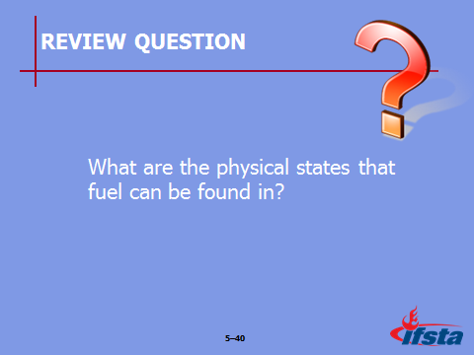
Review Question: What are the physical states that fuel can be found in?
See pages 223-231 of the manual for answers.

Section IV: Oxygen

Oxygen
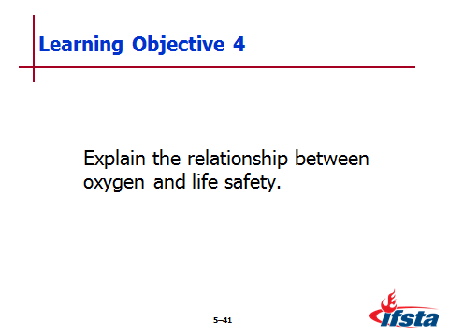
pp. 231-233 Objective 4 — Explain the relationship between oxygen and life safety.

Oxygen

Primary oxidizing agent in most fires – Consists of about 21 percent oxygen

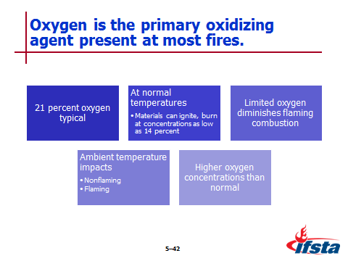
At normal ambient temperatures (68°F/20°C) – Materials can ignite, burn at oxygen concentrations as low as 14 percent

When oxygen is limited flaming combustion will diminish – Causing nonflaming combustion

Impact of ambient temperature

Nonflaming can continue at extremely low concentrations when surrounding temperature is relatively low

Flaming may continue at lower oxygen concentrations when temperature is high
Instructor Note: Discuss the Safety Alert on page 231 of the manual. Emphasize with students how oxygen concentration impacts both fire behavior and survival.

When oxygen concentration is higher than normal

Materials will burn more intensely, may ignite more readily

Some petroleum-based materials will autoignite

Materials that do not burn at normal levels will burn

Fires may be more difficult to extinguish, present safety hazard to firefighters

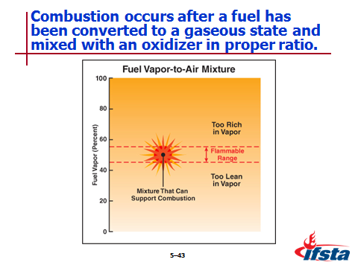
Combustion occurs after fuel has been converted to gaseous state when mixed with oxidizer in proper ratio

Range of concentrations called flammable (explosive) range

Reported using percent by volume of gas or vapor in air for

Lower flammable limit (LFL) – Minimum concentration of fuel vapor, air that supports combustion

Upper flammable limit (UFL) – Concentration above which combustion cannot take place

Ideal concentration for combustion is within flammable range
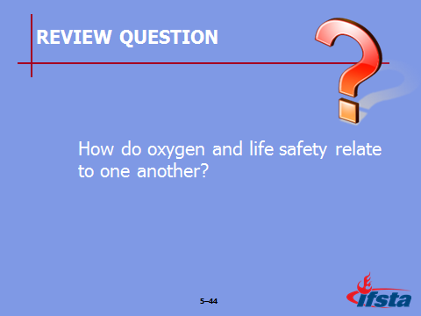
Review Question: How do oxygen and life safety relate to one another?
See pages 231-233 of the manual for answers.

Section V: Self-Sustained Chemical Reaction

Self-Sustained Chemical Reaction
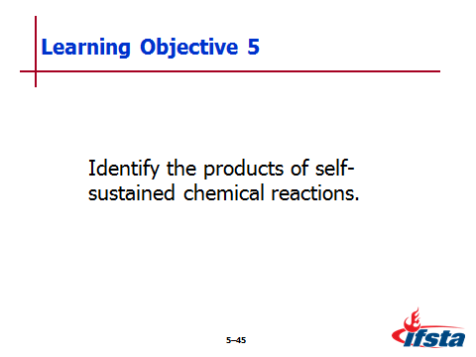
pp. 233-234 Objective 5 — Identify the products of self-sustained chemical reactions.

Self-Sustained Chemical Reaction

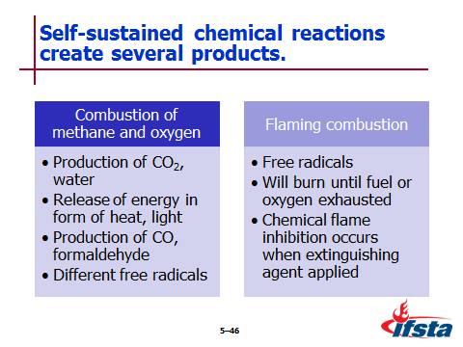
Example of complex reaction – Combustion of methane, oxygen

Complete oxidation of methane results in

Production of CO₂, water

Release of energy in form or heat, light

Molecules break apart as flaming combustion occurs – Form free radicals

Free radicals combine with oxygen or elements that form fuel material – Produce new substance; leads to more free radical production

Production of CO and formaldehyde occurs at various points in process – Both are flammable, toxic

Different free radicals, intermediate combustion products created based on type of chemically complex fuels that burn

Another example – Flaming combustion

Sufficient heat causes fuel, oxygen to form free radicals, initiate reaction

Fire will burn until fuel or oxygen exhausted or extinguishing agent applied in sufficient quantity to interfere with reaction

Chemical flame inhibition occurs when extinguishing agent

Interferes with chemical reaction

Forms stable product

Terminates combustion reaction
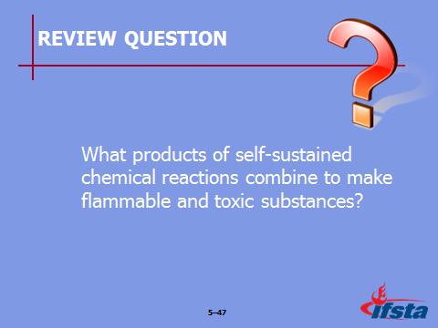
Review Question: What products of self-sustained chemical reactions combine to make flammable and toxic substances?
See pages 233-234 of the manual for answers.

Section VI: Stages of Fire Development

Stages of fire Development
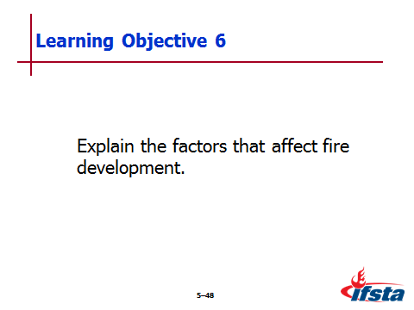
pp. 234-250 Objective 6 — Explain the factors that affect fire development.
Objective 7 — Describe the stages of fire development.

Stages of Fire Development

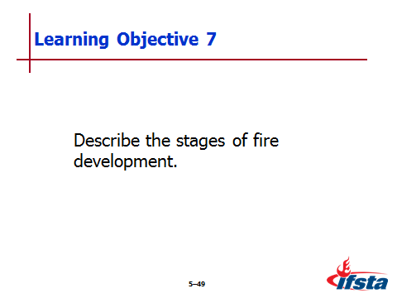
Occur in both unconfined, confined fires

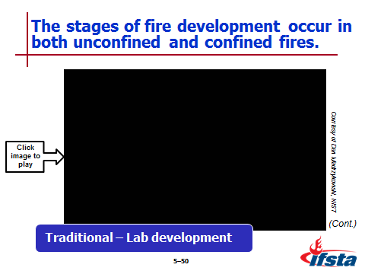
Distinct in laboratory simulations, not in exact sequence outside of laboratory
Video clip 00:20
No Sound

Single compartment used to illustrate fire progression – Actual conditions in multiple compartments vary widely

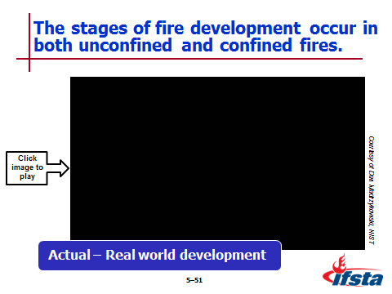
Used at fire scene as guide for what could occur, not a pattern of what will occur every time

Assess changing hazards, conditions at incident – Do not assume fire will follow laboratory pattern
Video clip 00:22
No Sound

Factors that Affect Fire Development

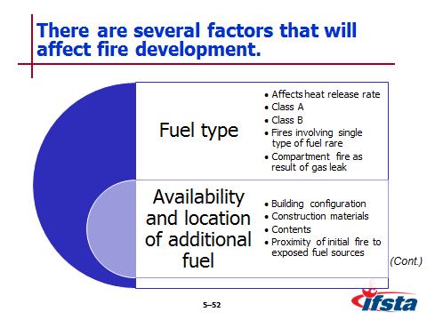
Fuel type

Affects heat release rate (HRR)

Class A fires – High surface-to-mass ratio materials more easily ignited, will burn more quickly

Class B fires – Influenced by surface area, type of fuel involved

Fires involving single type of fuel rare

Modern contents are largely petroleum-based materials – Have higher heat of combustion, produce higher HRRs than wood alone

Burning synthetic fuels – Products of combustion contain solid, liquid particulates and unburned gases

Compartment fire as result of flammable/combustible gas leak

May begin with rapid ignition of gas and explosion

If fuel source not controlled may burn at point of release, continue to adjacent combustibles

Shutting off fuel source or controlling leak may reduce, eliminate Class B fire – Resulting Class A fire will continue to burn

Availability and location of additional fuel

Building configuration (layout of structure) – Elements can contribute to fire spread or containment

Number of stories above or below grade

Compartmentation

Floor plan

Openings between floors

Continuous voids or concealed spaces

Barriers to fire spread

Construction materials – Can add to fuel load

Orientation and surface-to-mass ratio of structural materials influence rate, intensity of fire spread

Interior finishes can influence fire spread

Contents

Most readily available fuel source

When releasing large amount of heat rapidly – Increases intensity of fire, speed of development

Proximity of initial fire to exposed fuel sources

Fuels in upper level of adjacent compartments pyrolize more quickly

Continuous fuels rapidly spread fire from compartment to compartment

Location of fire within building will influence development

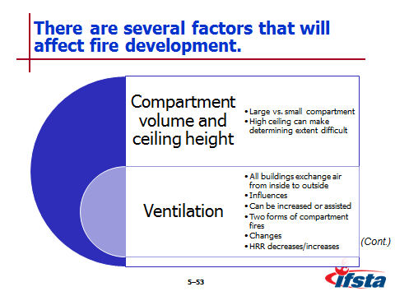
Compartment volume and ceiling height

All other factors being equal – Fire in large compartment will develop more slowly than in small compartment

Due to greater volume of air, increased distance radiated heat must travel from fire to contents

Large volume of air will support development of larger fire

High ceiling can make determining extent of fire development difficult

Large volume of hot smoke, fire gases can accumulate at ceiling level, while conditions at floor level remain unchanged

Do not mistake floor level conditions for actual state of fire development

Ventilation

All buildings exchange air from inside to outside

Constructed openings – Windows, doors, passive ventilation devices

Leakage through cracks, other gaps in construction

Heating, ventilating, and air conditioning (HVAC) system

Influenced by size, number, locations of openings, velocity of air being exchanged

Can be increased by natural conditions (wind direction, velocity) or assisted by HVAC system

Instructor Note: Discuss the Information Box “Ventilation vs. Tactical Ventilation” on page 239 of the manual. Be sure students understand the distinction between the exchange of air and tactical ventilation practices.

Two forms of compartment fires

Fuel controlled – Sufficient oxygen available; characteristics, configuration of fuel control development

Ventilation controlled

Available air supply begins to limit fire development in compartment fire

Fire has tendency to grow in direction of ventilation openings

Ventilation changes can

Alter flow path

Create rapid fire development

Place firefighters in extreme danger

When ventilation controlled – HRR decreases

Sudden introduction of air creates rapid increase in HRR

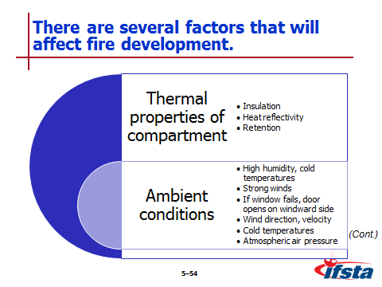
Thermal properties of the compartment – Can contribute to rapid fire development; make extinguishment difficult, reignition possible

Insulation – Contains heat within compartment causing localized increase in temperature, fire growth

Heat reflectivity – Increases fire spread through transfer of radiant heat from wall surfaces to adjacent fuel sources

Retention – Maintains temperature by absorbing, releasing large amounts of heat slowly

Ambient conditions

High humidity, cold temperatures – Can slow natural movement of smoke

Strong winds – Place additional pressure on side of structure, force both smoke, fire out opposite side

If window fails or door opens on windward side – Intensity, spread can increase significantly

Wind direction, velocity can prevent or assist in ventilation activities

Cold temperatures can cause smoke to appear white, give false impression of interior conditions

Atmospheric air pressure can cause smoke to remain close to ground obscuring visibility

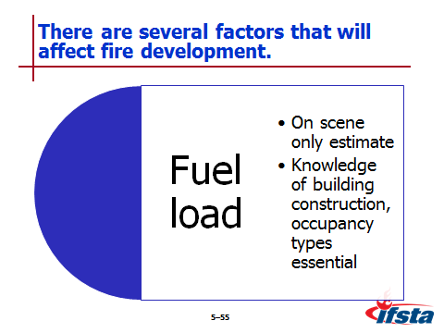
Fuel load – Total quantity of combustible contents of building, space, fire area

On scene you will only be able to estimate based on knowledge, experience

Knowledge of building construction, occupancy types will be essential to determining
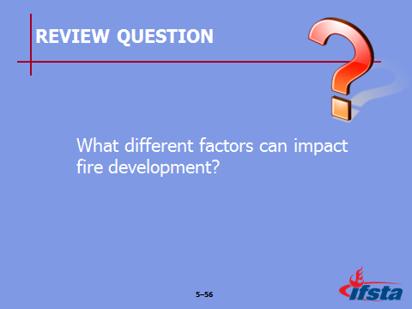
Review Question: What different factors can impact fire development?
See pages 234-241 of the manual for answers.

Incipient Stage

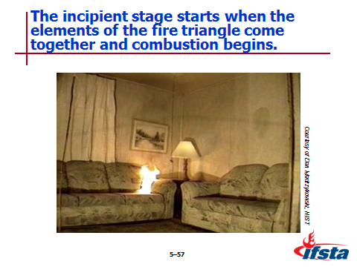
Starts ignition when three elements of fire triangle come together, combustion process begins

Fire is small, confined to material first ignited

Development

Largely dependent on characteristics, configuration of fuel involved

Air provides oxygen to continue

Radiant heat warms adjacent fuel, continues process of pyrolysis

Plume of hot gases, flame rises from fire and mixes with cooler air

As plume reaches ceiling, begins to spread horizontally across, forming ceiling jet

Process of heat transfer begins to increase overall temperature in room

Characteristics

Fire has not yet influenced environment to significant extent

Temperature only slightly above ambient

Concentration of combustion products low

Occupants can safely escape from compartment

Fire could be safely extinguished with portable extinguisher, small hoseline

Essential to recognize that transition from incipient to growth can occur quickly (even in seconds) depending on type, configuration of fuel

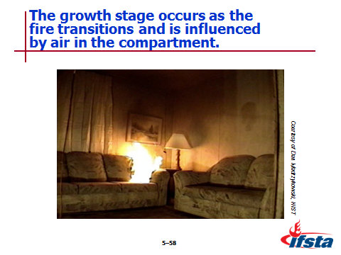
Growth Stage

As fire transitions

Begins to influence environment within compartment

Grown large enough for compartment configuration, amount of ventilation to influence it

Amount of air entrained in plume

Affected by location of fuel package in relation to compartment walls – Also impacts amount of cooling taking place

Unconfined fires draw from all sides, cools plume of hot gases, reducing flame length, vertical extension

Fuel packages in middle of room can entrain air from all sides

Fuel packages near walls can only entrain air from three sides

Fuel packages in corners can only entrain air from two sides

When fuel package not in middle of room – Combustion zone expands vertically, higher plume results

Higher plume increases temperature in developing hot-gas layer at ceiling level, increases speed of development

Heated surfaces around fire radiate heat back toward burning fuel, increases speed of development

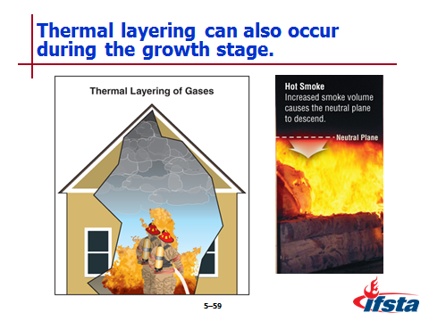
Thermal layering – Also referred to as heat stratification, thermal balance

Tendency of gases to form into layers according to temperature

Hottest gases tend to be in upper layer

Cooler gases tend to be in lower layer

Effects of heat transfer through radiation, convection

Radiation from hot gas layer heats interior surfaces of compartment, contents

Can be altered by change in ventilation, flow path

Pressure increases as volume, temperature do

Causes hot gas layer to spread downward within compartment, laterally through openings

Cool gas layer pressure lower – Results in inward movement of air from outside at bottom as hot gases exit top

Interface of hot, cooler gas layers at opening – Neutral plane

Pressure is neutral where layers meet

Only exists at openings where hot gases exiting, cooler air entering

When possible – Maintain or raise level of hot gas layer above floor

Provide more tenable environment for firefighters, trapped occupants

Use effective fire control, ventilation to raise position

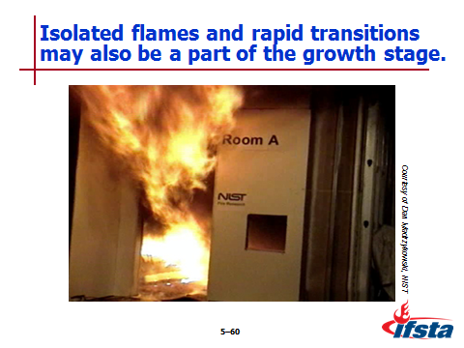
Isolated flames

May be observed moving though hot gas layer

Indicates that portions of layer are within flammable range, there is sufficient temperature to result in ignition

Frequently observed prior to more substantial involvement of flammable products of combustion in layer

Rapid transition

Flashover – From growth to fully developed stage

Occurs during growth stage in laboratory; may occur at any time conditions are right in uncontrolled situation

Does not occur at every fire

Development may take alternate path when ventilation limited

Ventilation control limits HRR, causing fire to enter decay stage

Most fires that develop beyond incipient stage become ventilation controlled

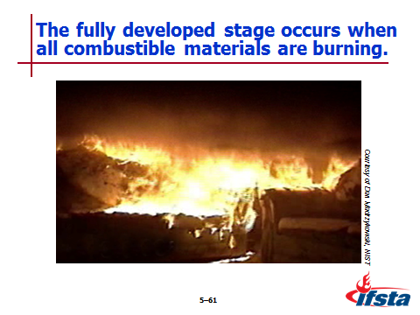
Fully Developed Stage

Occurs when all combustible materials in compartment are burning

Burning fuels in compartment are releasing maximum amount of heat possible for available fuel, oxygen; producing large volumes of fire gases

Is ventilation controlled because heat release is dependent on compartment openings

Provide oxygen, supports ongoing combustion, releases products of combustion

Increases in available air supply will result in higher heat release

Flammable products of combustion

Likely to flow from compartment of origin into adjacent compartments or out through openings to exterior of the building

Flames will extend out of compartment openings because insufficient oxygen for complete combustion in compartment
Note: If there are limited or no openings in the compartment, it is unlikely that the fire will reach a fully developed stage due to limited ventilation.

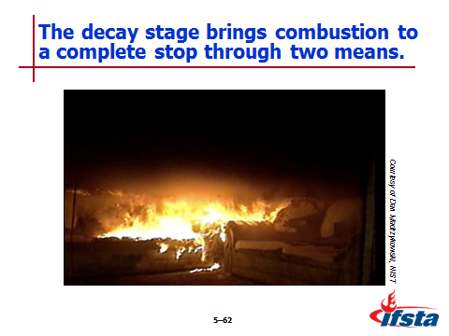
Decay Stage

Occurs

As fuel is consumed

If oxygen concentration falls to point that flaming combustion is diminished

Brings combustion reaction to stop

Consumption of fuel

As fuel is consumed, HRR begins to decline

With adequate ventilation, fire becomes fuel controlled

Temperature in compartment may remain high even after HRR drops

Flammable products of combustion can accumulate within compartment, adjacent spaces

Limited ventilation

HRR declines due to lack of oxygen

May maintain extremely high temperature within compartment

Pyrolysis can continue

Large volume of flammable products of combustion can accumulate
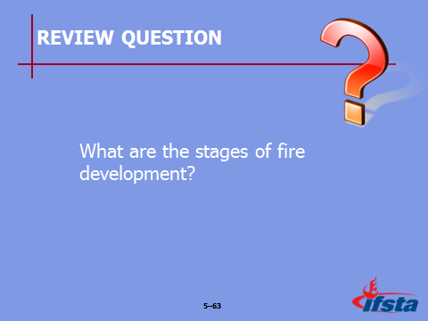
Review Question: What are the stages of fire development?
See pages 241-247 of the manual for answers.
pp. 247-250 Objective 8 — Recognize signs, causes, and effects of rapid fire development.

Rapid Fire Development

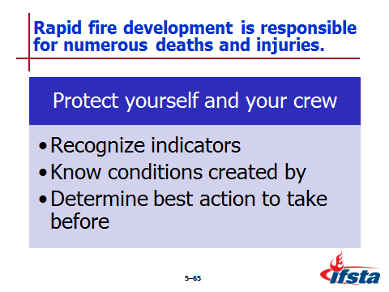
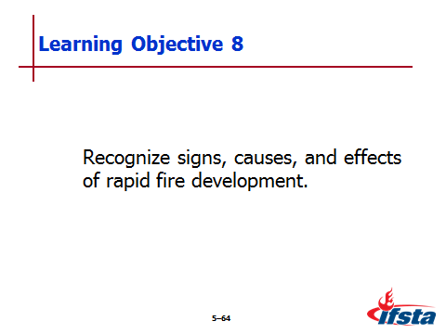
Responsible for numerous firefighter deaths, injuries

Protect yourself, crew

Recognize indicators

Know conditions created by situations

Determine best action to take before occurrence

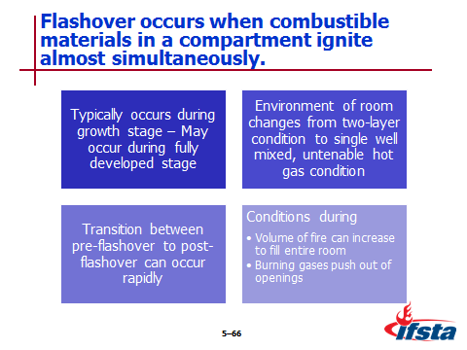
Flashover

Combustible materials in compartment, gases produced by pyrolysis ignite almost simultaneously – Full-room involvement

Typically occurs during growth stage – May occur during fully developed stage

Environment of room changes from two-layer condition to single well mixed, untenable hot gas condition

Transition between pre-flashover to post-flashover can occur rapidly

Conditions during

Volume of fire can increase from ¼ to ½ room’s upper volume to fill entire room – Potentially expanding out of any openings

Burning gases push out of openings at substantial velocity

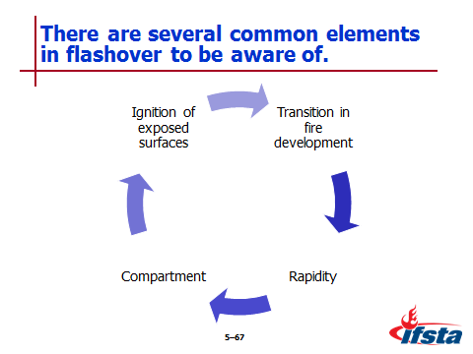
Common elements

Transition in fire development – Represents transition from growth stage to fully developed stage

Rapidity – Not an instantaneous event, but happens rapidly (often in seconds) to spread complete fire involvement within compartment

Compartment – Must be enclosed space such as single room or enclosure

Ignition of all exposed surfaces – Virtually all combustible surfaces in enclosed space become ignited

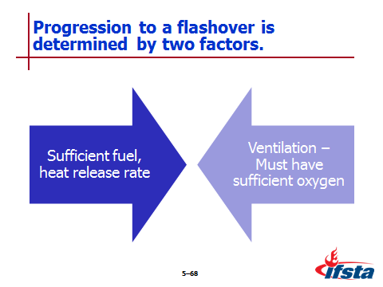
Factors that determine if fire will progress to flashover

Sufficient fuel, heat release rate

Ventilation – Must have sufficient oxygen

Survival rates extremely low – Typically occurs at 1,100ºF (600ºC) ceiling temperature

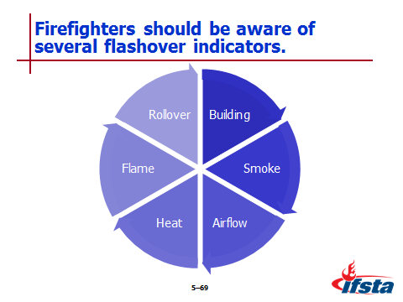
Be aware of indicators

Building indicators

Can occur in any building

Interior configuration, fuel load, thermal properties, ventilation will determine how rapidly

Smoke indicators – Rapidly increasing volume, turbulence, darkening color, optical density, lowering of hot gas level

Airflow indicators

High velocity, turbulence

Bi-directional movement with smoke exiting at top of doorway, fresh air moving in at bottom

Pulsing air movement

Heat indicators

Rapidly increasing temperature in compartment

Pyrolysis of contents or fuel packages located away from fire

Darkened windows

Hot surfaces

Flame indicators – Isolated flames in hot gas layers or near ceiling

Rollover also indicator

Condition where unburned fire gases at top of compartment ignite, flames propagate through hot gas layer or across ceiling

May occur during growth stage

Flames may be observed in layer while gases reach combustible temperature

Will generally precede, but will not always result in flashover

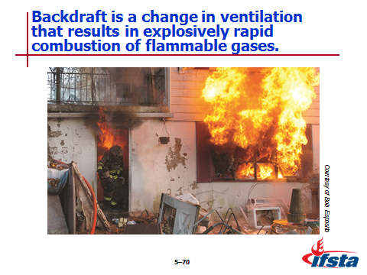
Backdraft

Increase in low-level ventilation prior to upper level ventilation results in explosively rapid combustion of flammable gases

Occurs in decay stage – In a space containing high concentration of heated flammable gases that lacks sufficient oxygen for flaming combustion

When potential conditions exist introduction of new source of oxygen will return fire to fully involved state – Can occur with creation of horizontal or vertical opening

Consider potential for before creating any openings into compartment

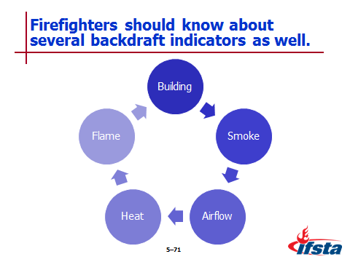
Be aware of indicators

Building indicators

Fire confined to single compartment or void space

Building contents have high heat release rate

Smoke indicators

Optically dense smoke, light colored or black becoming dense gray-yellow – Color alone is not reliable indicator

Neutral plane rising, lowering similar to pulsing or breathing movement

Airflow indicators – High velocity, turbulent smoke discharge, sometimes appearing to pulse or breath

Heat indicators – High heat, smoke stained windows

Flame indicators – Little or no visible flame

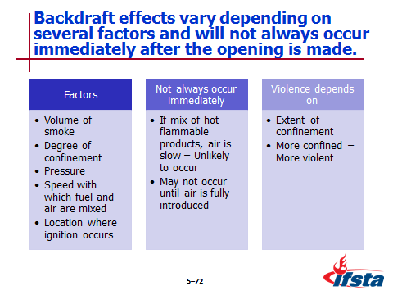
Effects vary depending on factors

Volume of smoke

Degree of confinement

Pressure

Speed with which fuel and air are mixed

Location where ignition occurs

Will not always occur immediately after opening made

If mix of hot flammable products, air is slow – Unlikely to occur

May not occur until air is fully introduced

Violence depends on extent of confinement – More confined, more violent backdraft will be

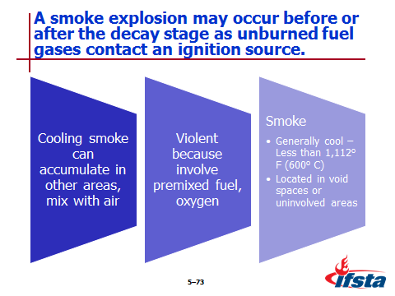
Smoke Explosion

May occur before or after decay stage

Occurs as unburned fuel gases contact ignition source

Cooling smoke can accumulate in other areas, mix with air – If contact ignition source while in flammable range, can result in explosively rapid combustion

Violent because involve premixed fuel, oxygen

Smoke generally cool, less than 1,112º F (600º C), located in void spaces connected to fire or in uninvolved areas remote
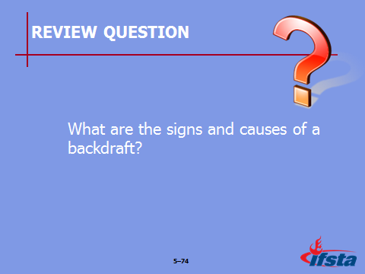
Review Question: What are the signs and causes of a backdraft?
See pages 248-250 of the manual for answers.

Section VII: Fire Behavior and Fire Fighting Operations

Fire Behavior and Fire Fighting Operations
pp. 250-253 Objective 9 — Describe the methods through which fire fighting operations can influence fire behavior.

Temperature Reduction

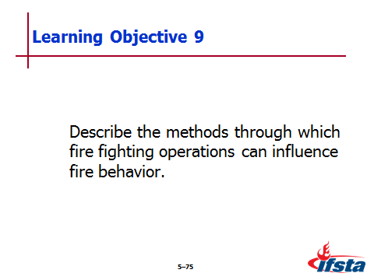
Most common method – Cooling with water

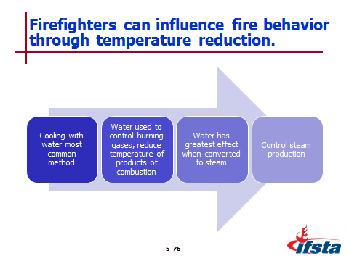
Enough must be applied to burning fuel to absorb heat generated by combustion

Reduces temperature of fuel to point where does not produce sufficient vapor to burn

Can extinguish solid, liquid fuels with high flash points

Cannot sufficiently reduce vapor production when low flash point flammable liquids, gases involved

Most effective method for extinguishment of smoldering fires

Water can also be used to control burning gases, reduce temperature of hot products of combustion in upper layer

Slows pyrolysis process

Reduces radiant heat flux from upper layer

Reduces potential for flashover

Water has greatest effect when vaporized into steam

Converted to steam at 212ºF (100ºC)

Expands 1,700 times – Avoid creating too much

Excess steam

Reduces visibility

Increase chances for steam burns

Disrupts thermal balance

Control steam production by

Using good nozzle technique

Applying appropriate amount of water

Applying water using most effective form of stream based on conditions

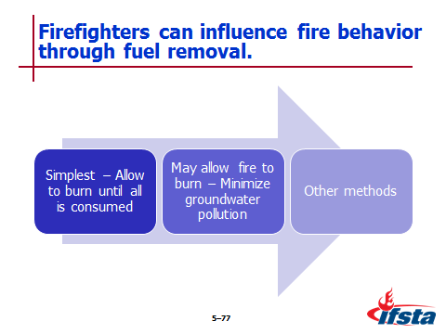
Fuel Removal

Simplest method – Allow fire to burn until all fuel consumed; not always desirable

Best solution may be to allow fire to burn, minimizing groundwater pollution

Other methods

Stop flow of liquid fuel

Close valves to stop emission of gaseous fuels

Move solid fuels out of path of fire

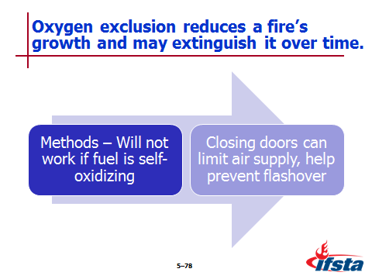
Oxygen Exclusion

Reduces fire’s growth, may totally extinguish over time

Methods – Do not work if fuel self-oxidizing

Flood area with inert gas to displace oxygen

Separate oxygen by blanketing fuel with foam

Closing doors before leaving building can limit air supply, help prevent flashover

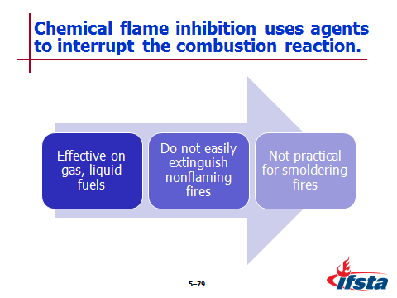
Chemical Flame Inhibition

Extinguishing agents interrupt combustion reaction, stop flame production

Effective on gas, liquid fuels

Do not easily extinguish nonflaming fires – No chemical chain reaction to inhibit

Not practical for smoldering fires

Ventilation and Fire Behavior

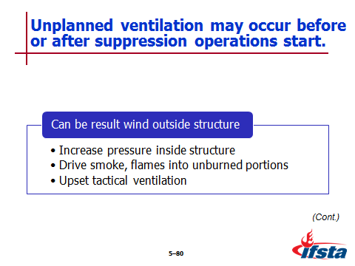
Unplanned ventilation – May occur before or after suppression operations start

Can result from wind outside structure – Impact

Increase pressure inside structure

Drive smoke, flames into unburned portions of structure, onto advancing firefighters

Upset tactical ventilation efforts
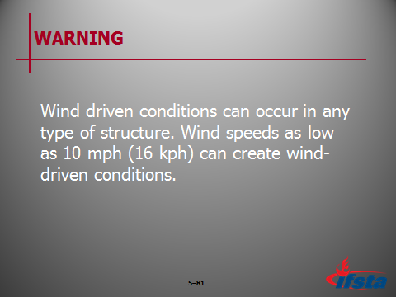
WARNING!: Wind driven conditions can occur in any type of structure. Wind speeds as low as 10 mph (16 kph) can create wind-driven conditions.

Can also be result of

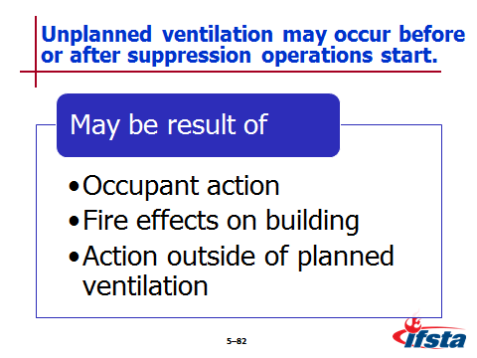
Occupant action

Fire effects on building

Action outside of planned, systematic, coordinated tactical ventilation

Ventilation strategies – Tactical ventilation

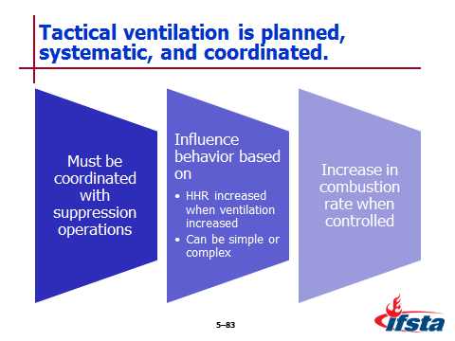
Planned, systematic, coordinated introduction of air; removal of hot gases, smoke from building

Must be coordinated with fire suppression operations to prevent unwanted consequences for hoseline crews

Influence on fire behavior based on variety of factors

HRR increased in ventilation-controlled fire when ventilation increased

Can be as simple as keeping exterior door closed or as complex as performing vertical ventilation

Increase in combustion rate when fire is ventilation controlled
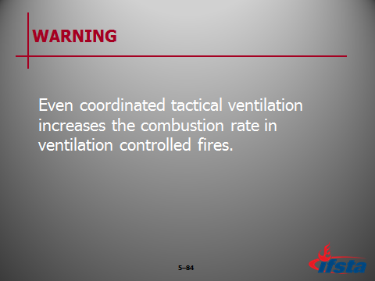
WARNING!: Even coordinated tactical ventilation increases the combustion rate in ventilation controlled fires.

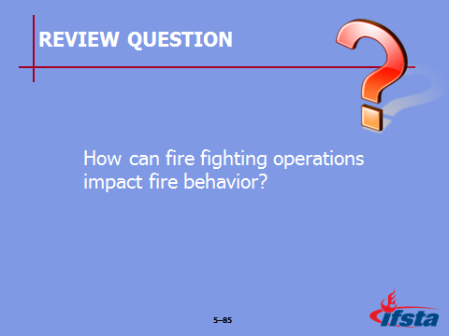
Review Question: How can fire fighting operations impact fire behavior?
See pages 250-253 of the manual for answers.

Section VIII: Summary and Review

SUMMARY AND REVIEW

Chapter Summary

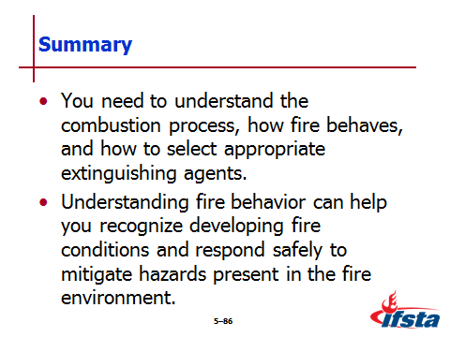
You need to understand the combustion process, how fire behaves, and how to select appropriate extinguishing agents.

Understanding fire behavior can help you recognize developing fire conditions and respond safely to mitigate hazards present in the fire environment.

Review Questions

How does the science of fire relate to energy, forms of ignition, and modes of combustion? (208-216)

What impact does thermal energy have on heat, temperature, and heat transfer? (216-223)

What are the physical states that fuel can be found in? (223-231)

How do oxygen and life safety relate to one another? (231-233)

What products of self-sustained chemical reactions combine to make flammable and toxic substances? (233-234)

What different factors can impact fire development? (234-241)

What are the stages of fire development? (241-247)

What are the signs and causes of a backdraft? (248-250)

How can fire fighting operations impact fire behavior? (250-253)

