Chapter 15
Fire Hose

Lesson Goal
After completing this lesson, the student shall be able to explain safety rules for service testing a fire hose.
Objectives
Upon successful completion of this lesson, the student shall be able to:
1. Describe the safety considerations taken when service testing a fire hose. [NFPA® 1001, 6.5.5]
2. Service test a fire hose. [NFPA® 1001, 6.5.5; Skill Sheet 15-II-1]

Instructor Information
This is the lesson covering service testing fire hose. This lesson describes safety considerations when service testing a fire hose.

Important instructor information is provided in shaded boxes throughout the lesson plan. Carefully review the instructor information before presenting the lesson.

This lesson includes a skill evaluation checklist that assesses student ability to perform a service test on a fire hose. This checklist will allow students to meet the requirements of learning objective 2.

Methodology
This lesson uses lecture, discussion, and a skills evaluation checklist. The level of learning is application.
Outline Contents

Section | Outline Pages | Text Pages
Section I: Service Testing Fire Hose | 5 | 872
Section II: Skill Sheets | 8 | 938
Section III: Summary and Review | 8 | 873

Audiovisuals
- Visuals 15.1 to 15.11 (PowerPoint® Presentation)
Evaluation
- Chapter 15 Quiz
- Chapter 15 Test
- Skill Evaluation Checklist 15-II-1
Presentation Tools
Interactive Objects allow instructors to present information a piece at a time by clicking on hot spots in a larger image.

Each object is labeled in the Lesson Outline and indicated in the PowerPoint® presentation by a RED arrow in the top left corner of the image. This lets instructors know to use the mouse to explore all of the information on the slide.


After all of the information is displayed a reset arrow will appear in the bottom right corner of the image. Instructors can use this to remove the text and quiz students on content just covered or simply move on to the next slide.

To move to the slide after an interactive object, select the Click for next slide arrow on the left side of the slide.

Videos are used as discussion starters or to illustrate a concept or process discussed in the chapter.

These are labeled in the Lesson Outline and indicated in the PowerPoint® presentation by the Click image to play arrow on the left side of the slide.

Section I: Service Testing Fire Hose

service testing fire hose
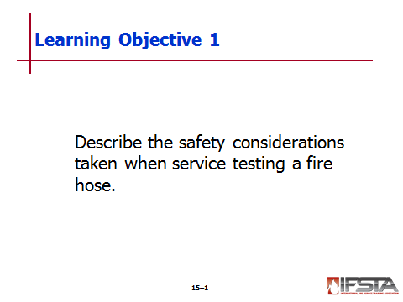
pp. 872-873 Objective 1 — Describe the safety considerations taken when service testing a fire hose.

Service Testing Fire Hose

Guidelines provided in NFPA® 1962, Standard for the Inspection, Care, and Use of Fire Hose, Couplings, and Nozzles and the Service Testing of Fire Hose

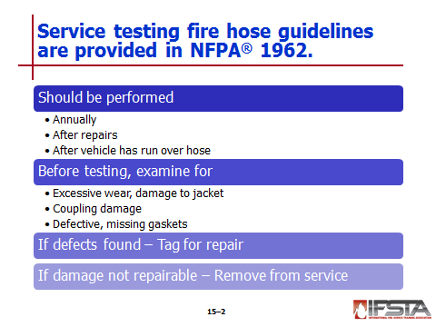
Should be performed annually, after repairs have been made, and after a vehicle has run over the hose

Before being service tested, hose should be examined for excessive wear or damage to jacket, coupling damage, and defective or missing gaskets

If defects found, hose should be tagged for repair

If damage is not repairable, hose should be removed from service

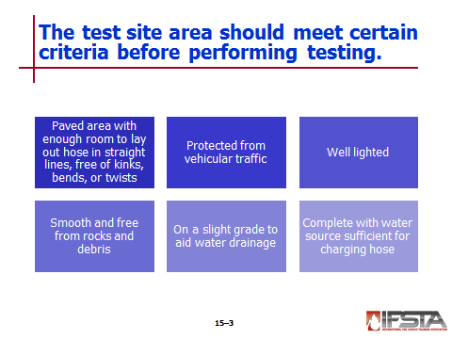
Test Site Preparation

Test area should be

Paved area with enough room to lay out hose in straight lines, free of kinks, bends, or twists

Protected from vehicular traffic

Well lighted

Smooth and free from rocks and debris

On a slight grade to aid water drainage

Complete with water source sufficient for charging hose

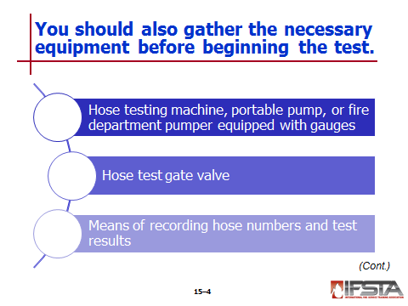
Necessary equipment

Hose testing machine, portable pump, or fire department pumper equipped with gauges certified as accurate within one year before testing

Hose test gate valve

Means of recording hose numbers and test results

Tags or other means to identify sections that fail

Nozzles with shutoff valves

Means of marking each length with year of test

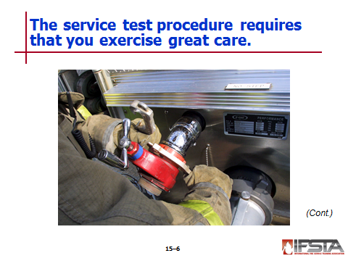
Service Test Procedure

Exercise care, especially when hose is under pressure
Instructor Note: This information correlates with Skill Sheet 15-II-1. More information is found at the end of this lesson outline.

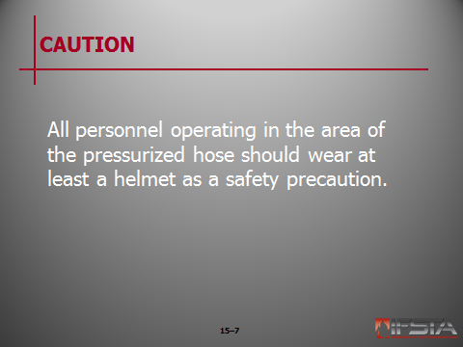
CAUTION: All personnel operating in the area of the pressurized hose should wear at least a helmet as a safety precaution.

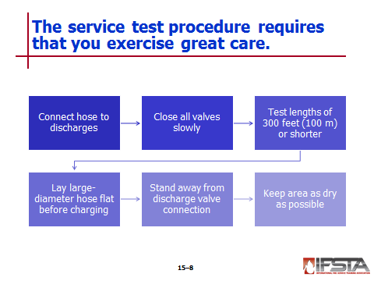
Connect hose to discharges on side of apparatus opposite pump panel

Close all valves slowly to prevent water hammer

Test lengths of hose 300 feet (100 m) in length or shorter

Lay large-diameter hose flat on ground before charging it

Stand away from discharge valve connection when charging hose

Keep hose testing area as dry as possible when filling and discharging air from hose
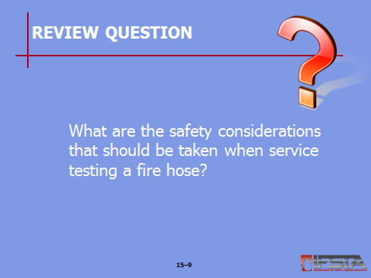
Review Question: What are the safety considerations that should be taken when service testing a fire hose?
See pp. 872-873 of the manual for answers.

Section II: Skill Sheets

SKILL SHEETS
p. 939 Objective 2 — Service test a fire hose.

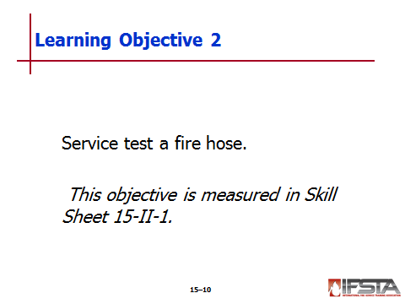
Skill Sheet 15-II-1

For this skill sheet, students will perform the skills to service test a fire hose

This skill sheet can be found in the Skills Evaluation Checklist 15-II-1 on the curriculum flash drive

This checklist corresponds with the information on p. 872-873 of the manual

Section III: Summary and Review

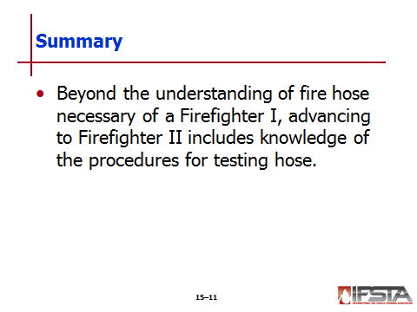
SUMMARY AND REVIEW

Chapter Summary

Beyond the understanding of fire hose necessary of a Firefighter I, advancing to Firefighter II includes knowledge of the procedures for testing hose.

Review Questions

What are the safety considerations that should be taken when service testing a fire hose? (872-873)

