Chapter 10
Scene Lighting, Rescue Tools, Vehicle Extrication, and Technical Rescue
Lesson Goal
After completing this lesson, the student shall be able to identify emergency scene lighting equipment.
Objectives
Upon successful completion of this lesson, the student shall be able to:
1. Identify types of emergency scene lighting equipment. [NFPA® 1001, 5.3.17]
Instructor Information
This is the lesson covering emergency scene lighting equipment.

Important instructor information is provided in shaded boxes throughout the lesson plan. Carefully review the instructor information before presenting the lesson.

Methodology
This lesson uses lecture and discussion. The level of learning is comprehension.
Outline Contents

Section | Outline Pages | Text Pages
Section I: Emergency Scene Lighting Equipment | 5 | 479
Section II: Summary and Review | 11 | 549

Audiovisuals
- Visuals 10.1 to 10.11 (PowerPoint® Presentation)

Evaluation
- Chapter 10 Quiz
- Chapter 10 Test
Presentation Tools
Interactive Objects allow instructors to present information a piece at a time by clicking on hot spots in a larger image.

Each object is labeled in the Lesson Outline and indicated in the PowerPoint® presentation by a RED arrow in the top left corner of the image. This lets instructors know to use the mouse to explore all of the information on the slide.


After all of the information is displayed a reset arrow will appear in the bottom right corner of the image. Instructors can use this to remove the text and quiz students on content just covered or simply move on to the next slide.

To move to the slide after an interactive object, select the Click for next slide arrow on the left side of the slide.

Videos are used as discussion starters or to illustrate a concept or process discussed in the chapter.

These are labeled in the Lesson Outline and indicated in the PowerPoint® presentation by the Click image to play arrow on the left side of the slide.

Section I: Emergency Scene Lighting Equipment

Emergency Scene Lighting Equipment
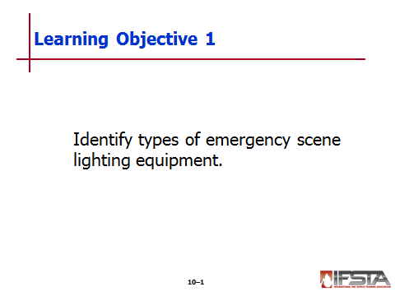
pp. 479-484 Objective 1 — Identify types of emergency scene lighting equipment.

Emergency Scene Lighting Equipment

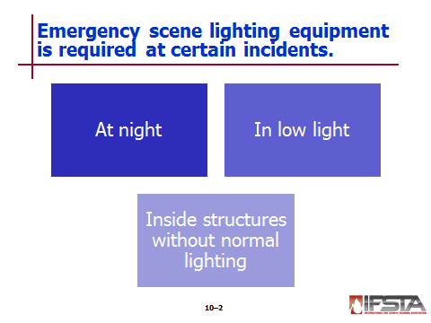
Required at all incidents that occur

At night

In low-light conditions

Inside structures where normal lighting not available

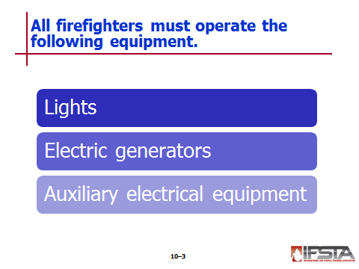
Equipment includes

Lights

Electrical generators

Auxiliary electrical equipment

Electric Generators

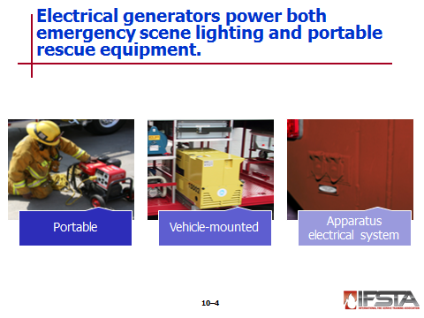
Power emergency scene lighting and portable rescue equipment

Most common power source used by emergency services personnel

Portable electric generators

Powered by small gasoline or diesel engines

Have 110- and/or 220-volt capacity outlets

Most light enough to be carried by two people

Useful when vehicle-mounted systems not available

Vehicle-mounted generators

Produce more power than portable units

Powered by gasoline, diesel, propane gas engines or hydraulic or power take-off (PTO) systems

Typically have 110- and 220-volt outlets, produce more than 50 kW of power

Disadvantages

Noisy if equipped with a separate engine – Makes communication difficult

Exhaust fumes may contaminate scene if vehicle not positioned downwind
Instructor Note: Discuss the Safety Box “Hearing Protection is Required when Using Generators” on page 480 of the manual. Emphasize with students the importance of wearing hearing protection.

Apparatus electrical system

Used for small amounts of power needed to operate lights and tools

Inverter converts 12- or 24-volt direct current (DC) into 110- or 220-volt alternating current (AC)

Advantages – Fuel efficiency, minimal noise

Disadvantages – Constant apparatus exhaust, limited power supply, limited mobility

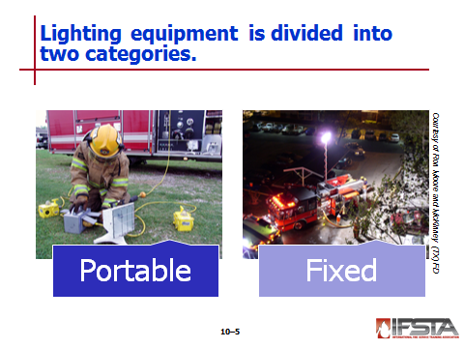
Lighting Equipment – Two categories

Portable lights

Used in building interiors or remote areas of scene

Range from 300 to 1,000 watts

Typically have carrying handles and large bases for stability

Some mounted on telescoping stands – Allows them to be raised and directed more effectively

Fixed lights

Mounted on vehicle, wired directly to vehicle-mounted generator or apparatus electrical system

Used to provide overall lighting of scene

Usually mounted on telescoping poles – Can be raised, lowered, rotated

Some consist of large banks of lights mounted on hydraulically operated booms – Generally have capacity of 500 to 1,500 watts per light

Number of units mounted on apparatus limited by amount of power produced by vehicle-mounted generator or apparatus electrical system
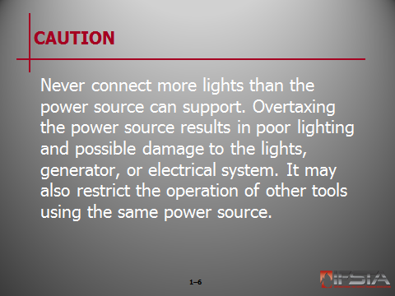
CAUTION: Never connect more lights than the power source can support. Overtaxing the power source results in poor lighting and possible damage to the lights, generator, or electrical system. It may also restrict the operation of other tools using the same power source.

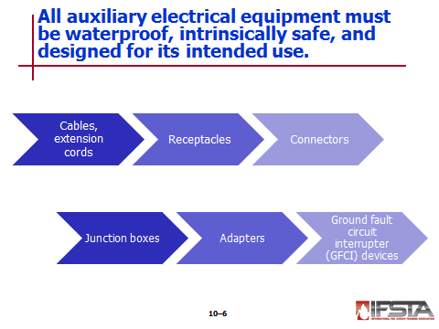
Auxiliary Electrical Equipment

Consists of following

Electrical cables

Extension cords

Receptacles

Connectors

Junction boxes

Adapters

Ground fault circuit interrupter (GFCI) devices

Must be waterproof, intrinsically safe, designed for amount of electrical current intended to carry

Electrical cables and extension cords

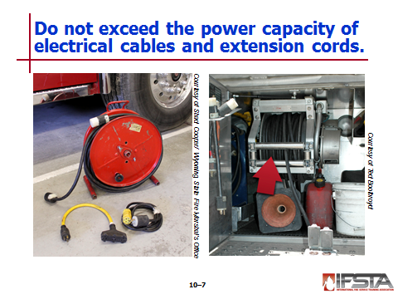
Can only carry limited amount of electricity

Do not use with equipment whose power demands exceed cord capacity – Creates electrical hazard, can damage equipment

May be stored in coils, on portable cord reels, or on apparatus-mounted automatic rewind reels

Should have adequate insulation, no exposed wires

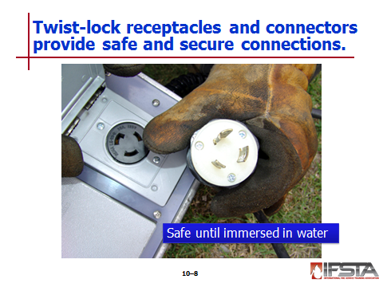
Twist-lock receptacles and connectors equipped with grounding wires – Provide secure, safe connections as long as not immersed in water

Junction boxes

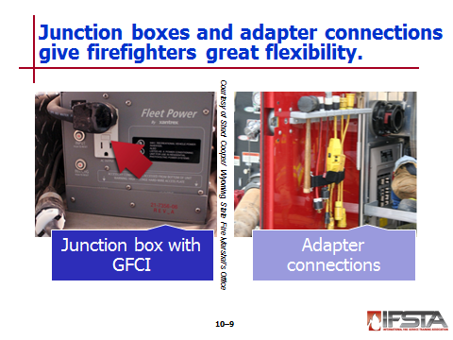
Provide multiple outlets or connections supplied through one inlet from power source

All outlets must be equipped with ground fault circuit interrupter (GFCI) devices, must meet requirements of NFPA® 70E

Adapter connections

Used to permit different types of plugs and receptacles to be connected together

Allow mutual aid departments to operate electrical lights and tools off each other’s generators and power sources

May also allow fire department lights and tools to be plugged into standard electrical outlets in structures
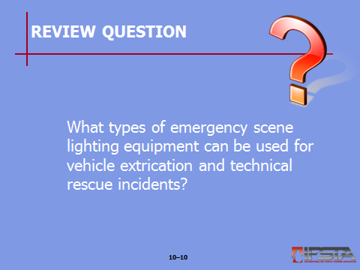
Review Question: What types of emergency scene lighting equipment can be used rescue incidents?
See pages 479-484 of the manual for answers.

Section II: Summary and Review

SUMMARY AND REVIEW

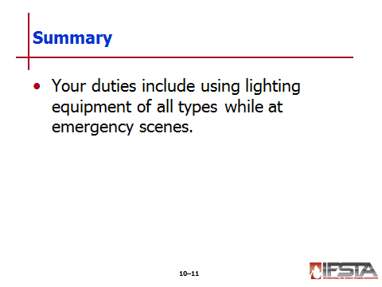
Chapter Summary

Your duties include using lighting equipment of all types while at emergency scenes.

Review Questions

What types of emergency scene lighting equipment can be used for rescue incidents? (479-484)

